尚硅谷大数据项目之在线教育实时数仓（数据接口大屏展示）

（作者：尚硅谷研究院）

版本：V1.0

# 第1章 数据可视化接口

## 1.1 设计思路

DWS 层把轻度聚合的结果保存到 ClickHouse 中，主要的目的就是提供即时的数据查询、统计、分析服务。这些统计服务一般会以两种形式呈现，一种是面向专业数据分析人员准备的 BI 工具，一种是面向非专业人员的更加直观的数据大屏。

本项目将面向 sugar 数据大屏开发数据接口服务。

## 1.2 需求梳理

### 1.2.1 最终显示效果图

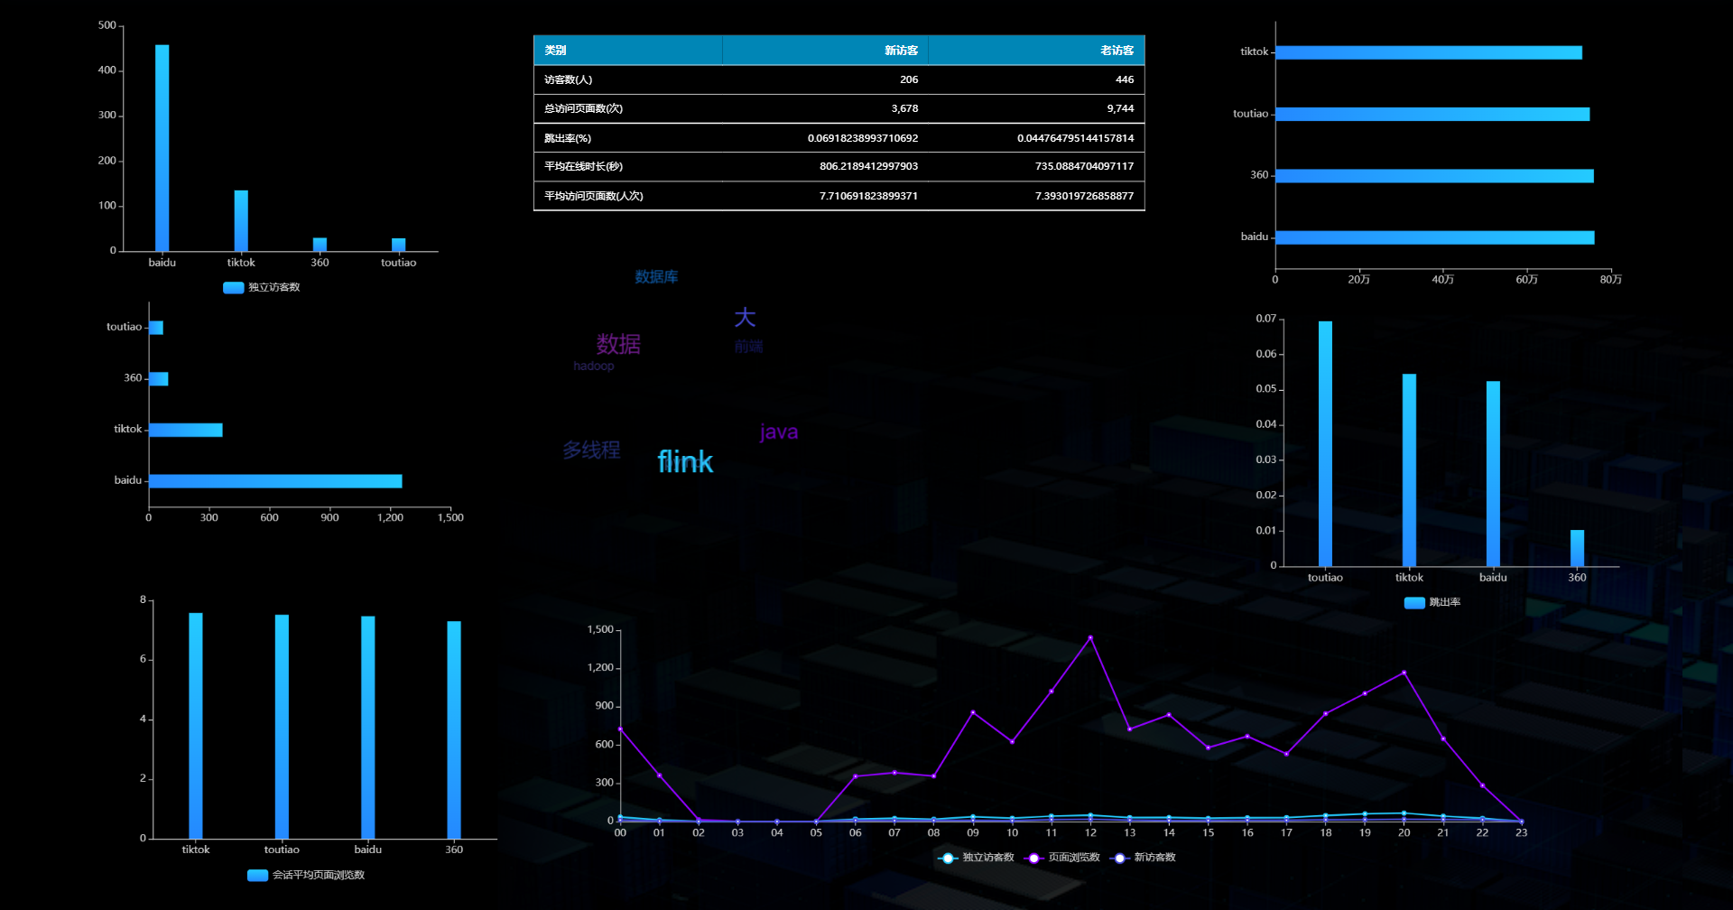

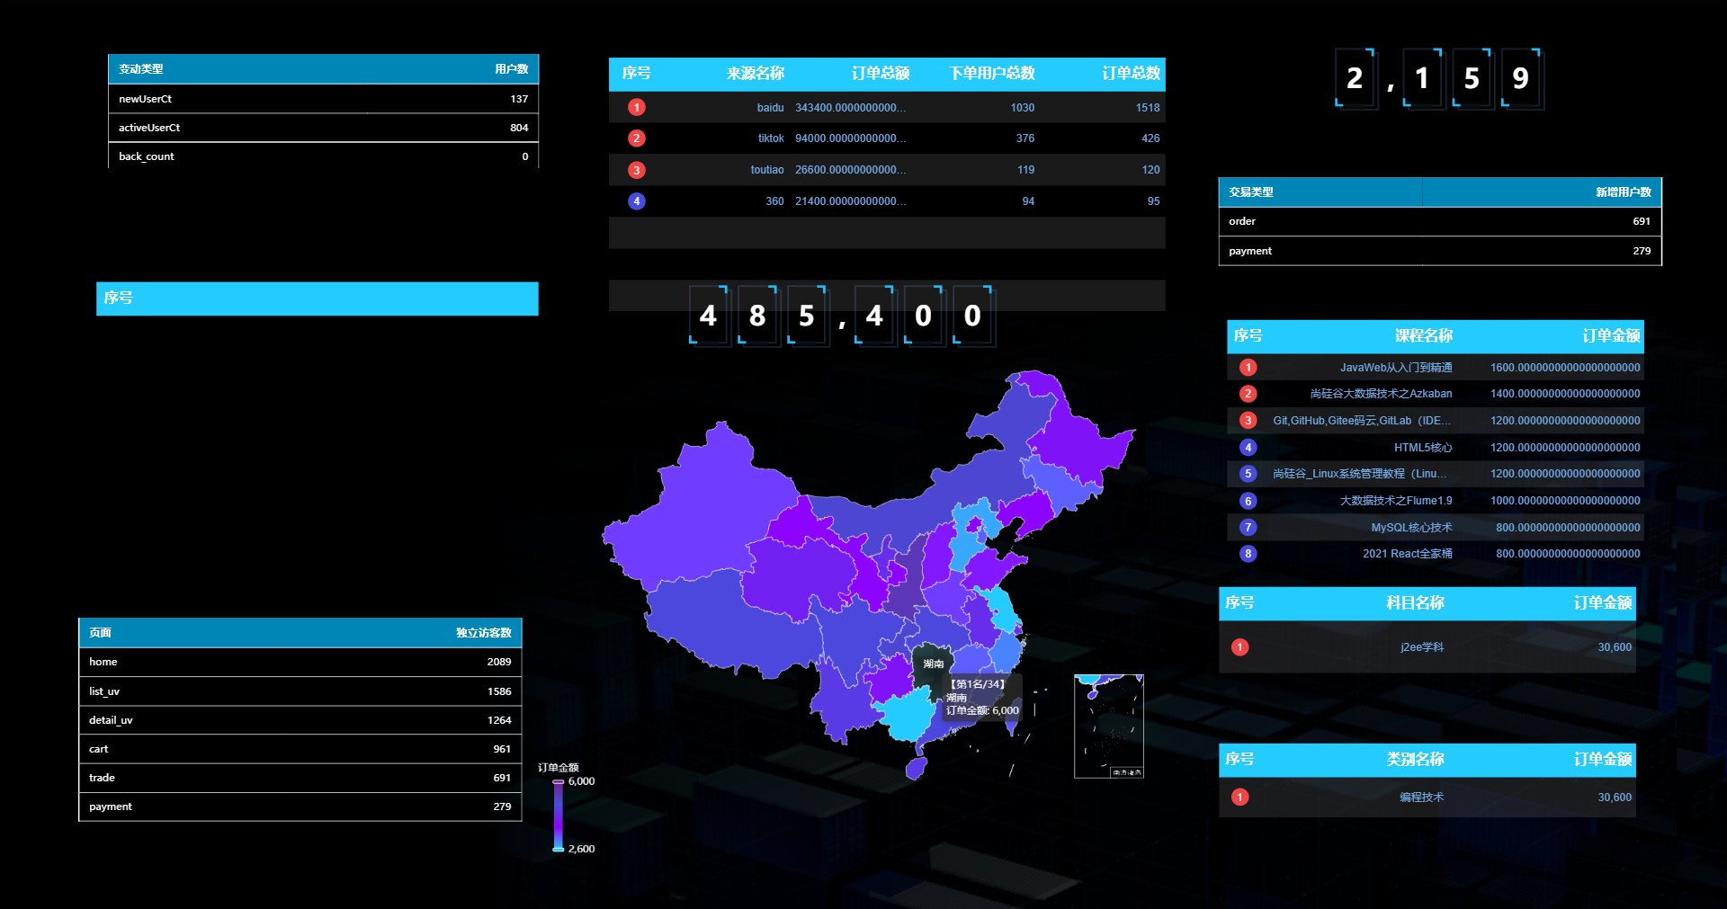

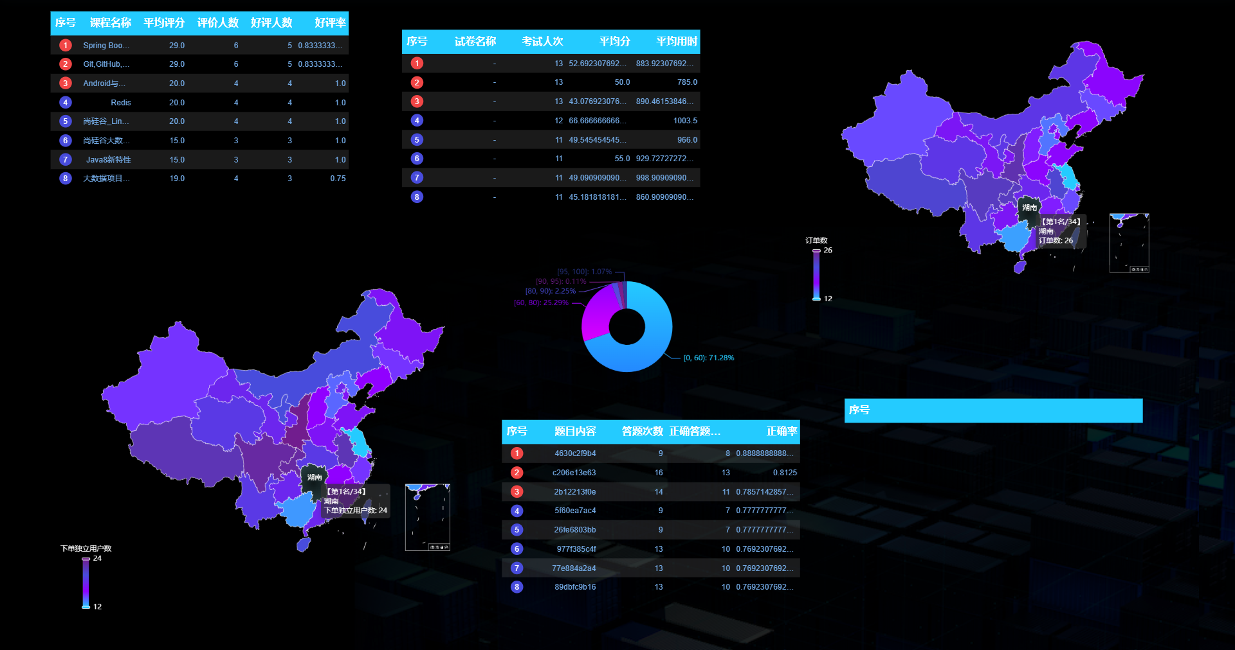

### 1.2.3 接口执行过程

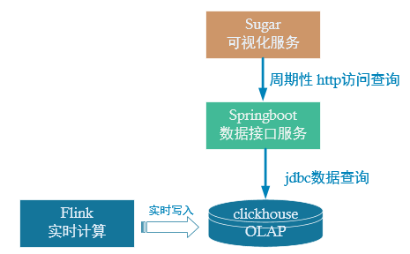

DWS 层计算结果存储在 ClickHouse，本项目将开发数据接口查询ClickHouse中的数据，提供给 Sugar 进行大屏展示。这里主要有两项工作：

* 配置可视化大屏服务。
* 编写数据查询接口以供可视化大屏进行访问。

# 第2章 环境准备

## 2.1 sugar 简介

### 2.1.1 产品介绍

Sugar是百度云推出的敏捷 BI 和数据可视化平台，目标是解决报表和大屏的数据 BI 分析和可视化问题，解放数据可视化系统的开发人力。

### 2.1.2 使用入口

<https://cloud.baidu.com/product/sugar.html>

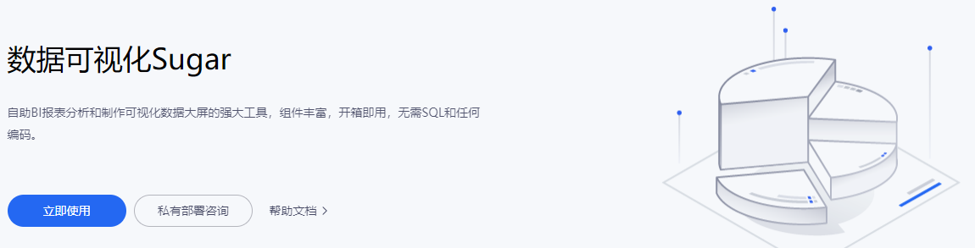

### 2.1.3 创建数据大屏

**1）点击【立即使用】后，登录百度账号**

**2）然后首先创建组织**

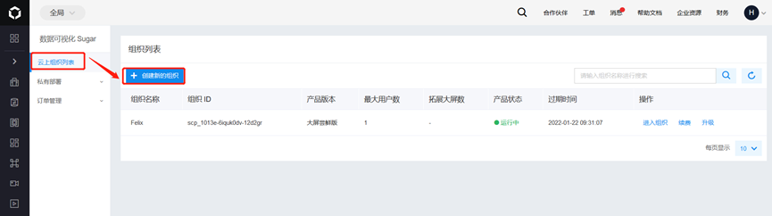

**3）创建中选择产品【大屏尝鲜版】，首次使用有一个月的试用期**

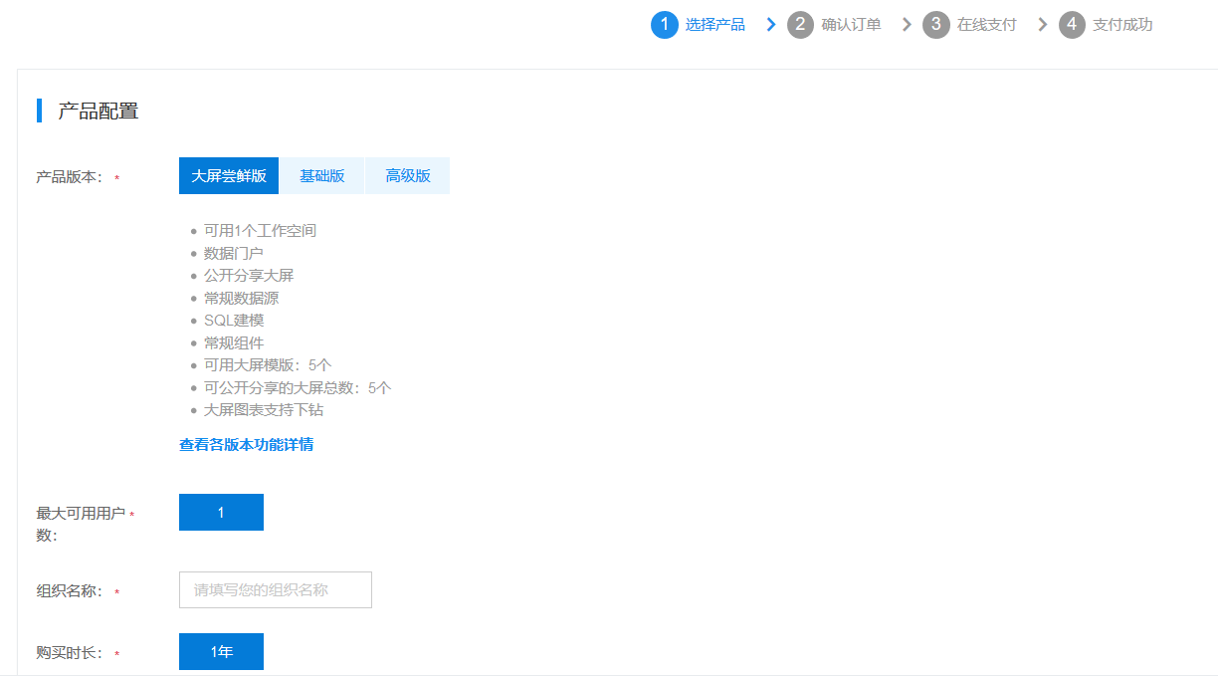

**4）新建好组织后选择【进入组织】**

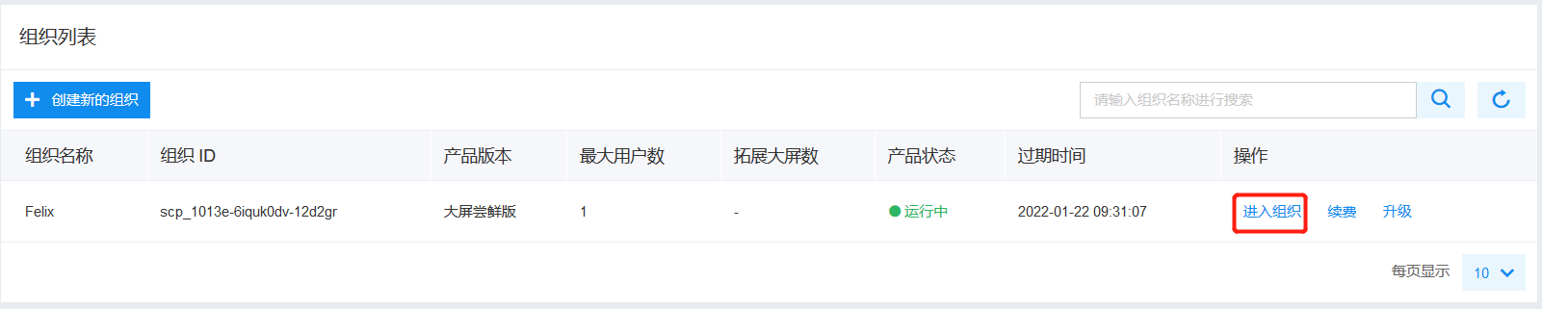 **5）然后进入默认的【第一个空间】**

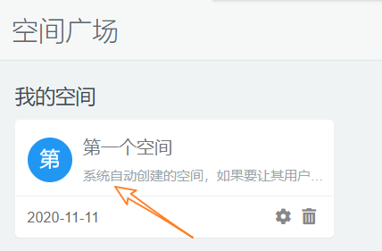

**6）在空间中选择【待创建大屏】后的【新建】**

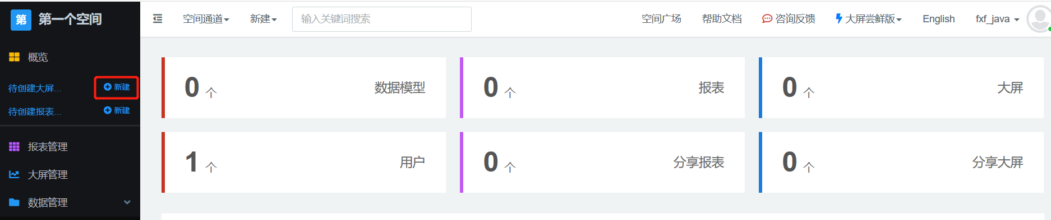

**7）选择大屏的模板**

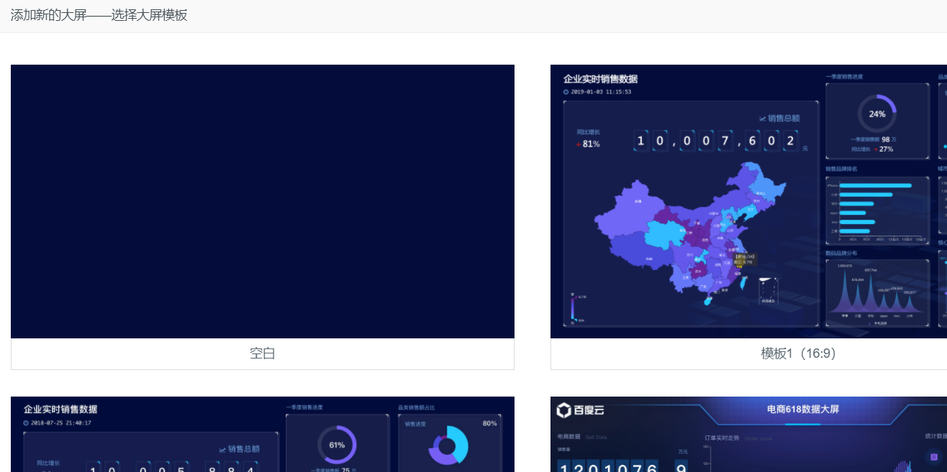

**8）可以选空模板，也可以根据现有的模板进行修改**

我们这里选择空白模板，并指定大屏的名称

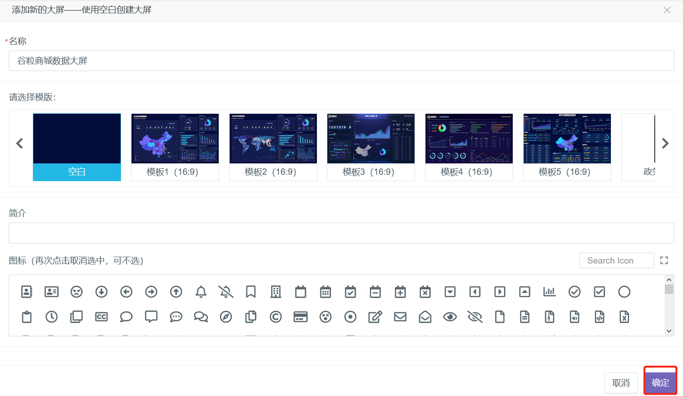

**9）进入大屏的编辑窗口**

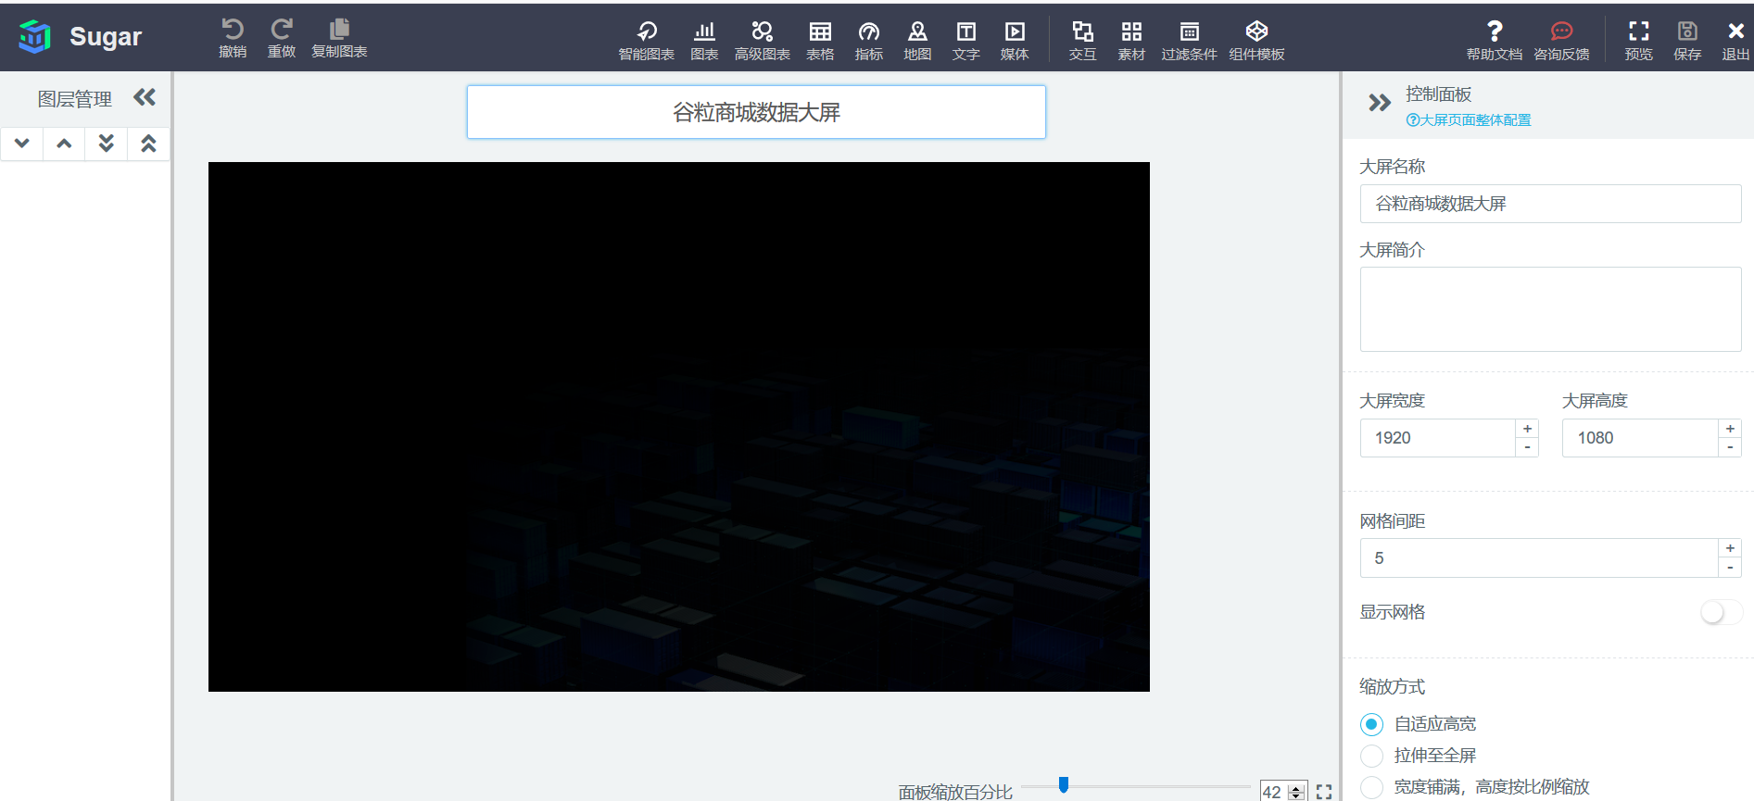

## 2.2 SpringBoot 开发环境构建

### 2.2.1 步骤

**1）在 edu-realtime-2022 项目下新建模块 edu-2022-publisher**

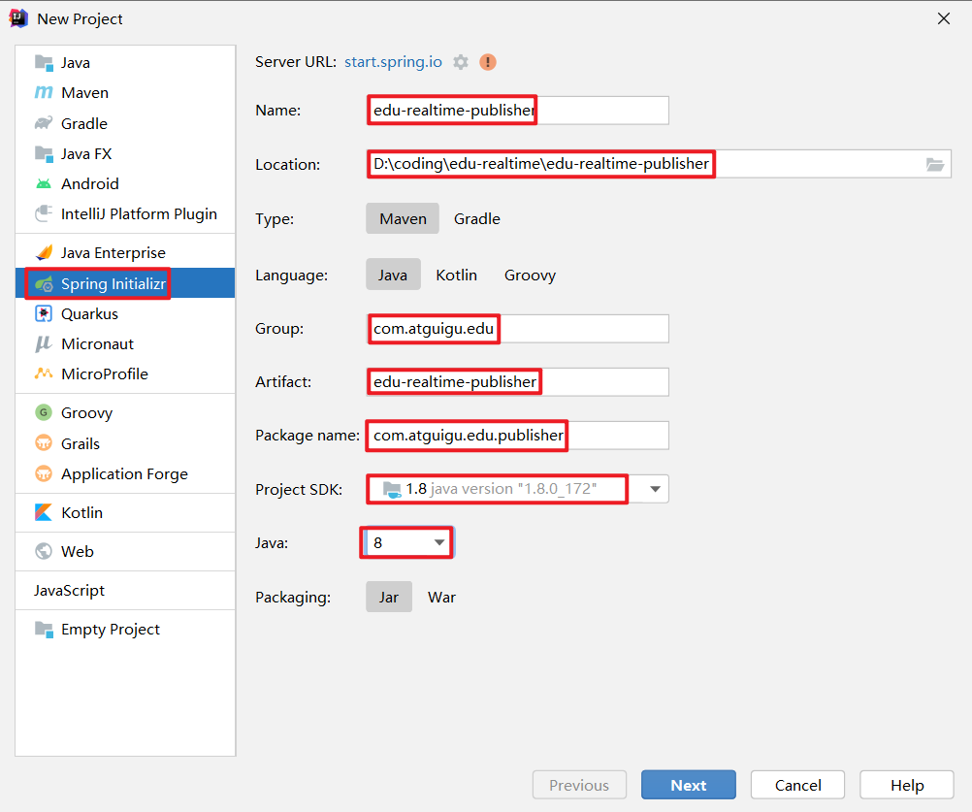

此处不勾选，在 pom 文件中添加依赖。

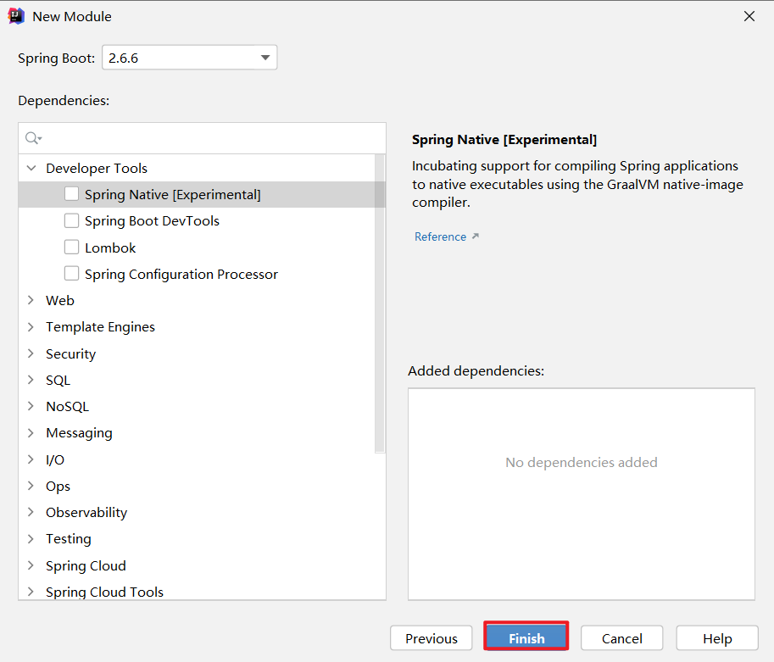

**2）添加依赖**

<dependencies>

<dependency>

<groupId>org.springframework.boot</groupId>

<artifactId>spring-boot-starter-jdbc</artifactId>

</dependency>

<dependency>

<groupId>org.springframework.boot</groupId>

<artifactId>spring-boot-starter-web</artifactId>

</dependency>

<dependency>

<groupId>org.mybatis.spring.boot</groupId>

<artifactId>mybatis-spring-boot-starter</artifactId>

<version>2.1.3</version>

</dependency>

<dependency>

<groupId>org.projectlombok</groupId>

<artifactId>lombok</artifactId>

<optional>true</optional>

</dependency>

<dependency>

<groupId>org.springframework.boot</groupId>

<artifactId>spring-boot-starter-test</artifactId>

<scope>test</scope>

<exclusions>

<exclusion>

<groupId>org.junit.vintage</groupId>

<artifactId>junit-vintage-engine</artifactId>

</exclusion>

</exclusions>

</dependency>

<dependency>

<groupId>org.apache.commons</groupId>

<artifactId>commons-lang3</artifactId>

<version>3.11</version>

</dependency>

<dependency>

<groupId>ru.yandex.clickhouse</groupId>

<artifactId>clickhouse-jdbc</artifactId>

<version>0.1.55</version>

</dependency>

</dependencies>

**3）目录结构如下**

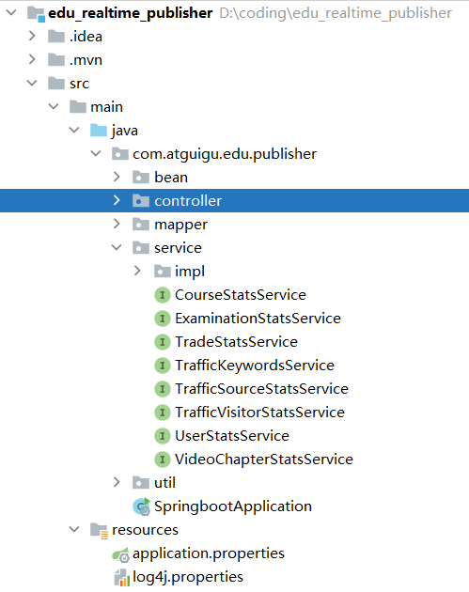

**4）在 application.properties 内添加如下内容**

SpringBoot 内嵌了 Tomact，默认端口为 8080。集群 Zookeeper 版本为 3.5.7，该版本提供的 AdminServer 服务端口号也是 8080，为了避免端口冲突，此处将 SpringBoot 内嵌的 Tomcat 容器端口号修改为 8070。

接口对接的数据库为 ClickHouse，需要指定驱动及 url。

server.port=8070

#配置ClickHouse驱动以及URL

spring.datasource.driver-class-name=ru.yandex.clickhouse.ClickHouseDriver

spring.datasource.url=jdbc:clickhouse://hadoop102:8123/edu_realtime

### 2.2.2 SpringBoot 项目分层

**1）表示层（也叫控制层）**

主要任务是拦截并处理请求。表示层代码通常在 controller 包下。

**2）业务层**

业务层代码通常在 service 包下。

service 下会有个名为 impl 的子包，里面放置 service 层接口的实现类。

实现类类名规范：接口名后面加Impl

**3）持久层**

和数据库交互，最常用的框架是 Mybatis，所以也叫 Mapper 层。

持久层代码通常在 mapper 包下。

## 2.3 内网穿透

### 2.3.1 内网穿透简介

内网即局域网。假设局域网中有一台电脑部署了web服务，现在希望所有人都能访问它。很显然，这台电脑只有一个局域网ip，没有公网ip。同一局域网内的设备可以通过局域网ip访问此电脑，而局域网之外的设备无法访问。

内网穿透可以将 ip + 端口唯一标识的本机服务映射为公网域名，局域网之外的设备可以通过该域名访问本机服务。

### 2.3.2 实现步骤

本项目将使用NATAPP内网穿透工具。

地址为 https://natapp.cn/

1）原理

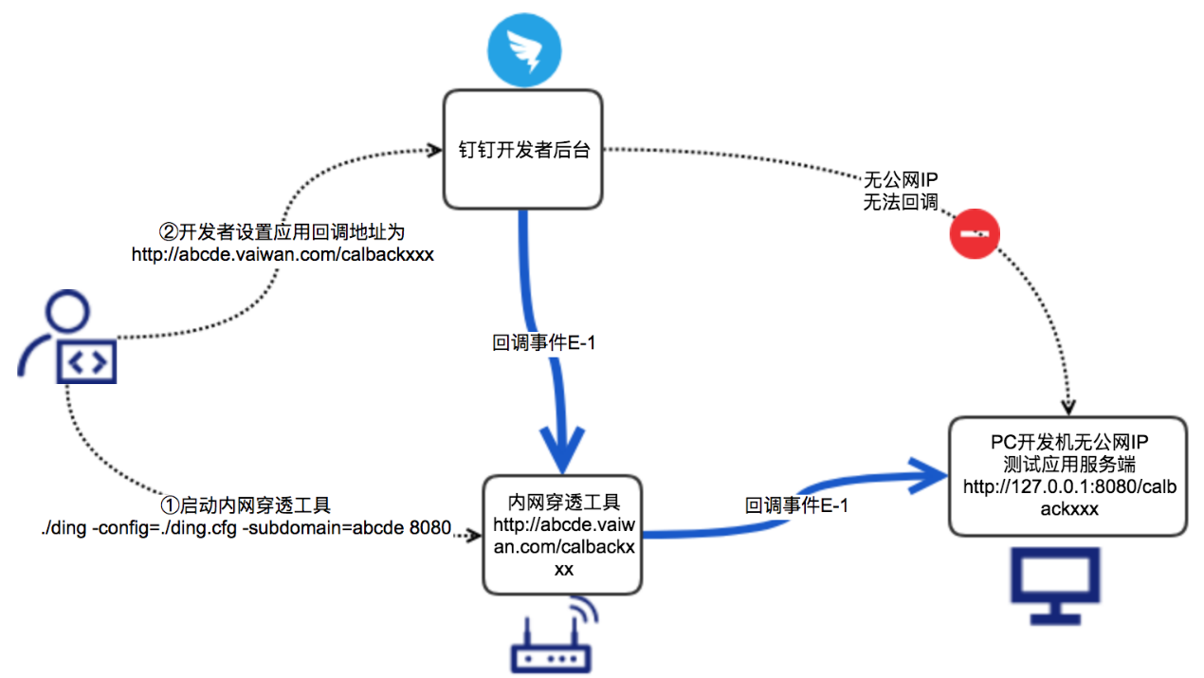

2）步骤

官网下载

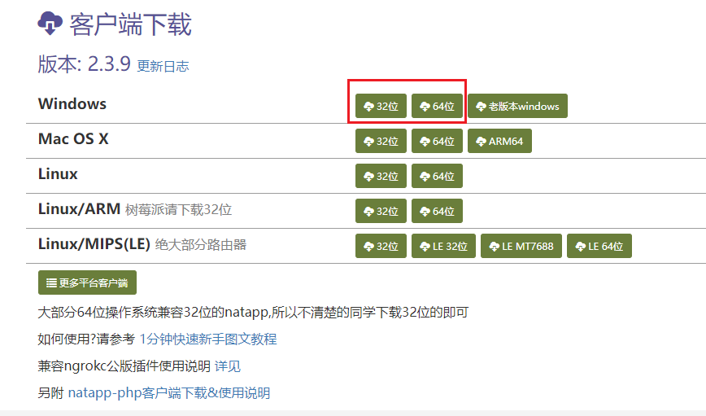

之后自己注册账号购买免费的通道

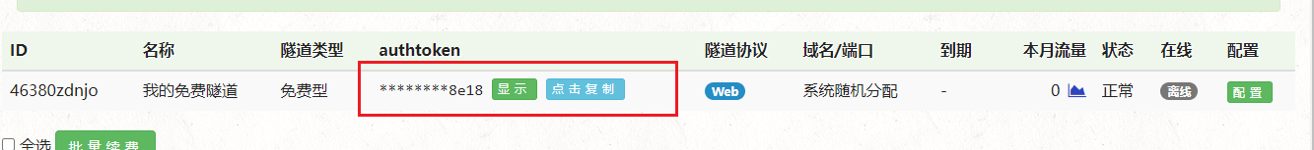

之后再同级目录下添加配置文件

#将本文件放置于natapp同级目录 程序将读取 [default] 段

#在命令行参数模式如 natapp -authtoken=xxx 等相同参数将会覆盖掉此配置

#命令行参数 -config= 可以指定任意config.ini文件

[default]

authtoken=xxxxxxxxxxxxxx18 #对应一条隧道的authtoken要自己免费去获取

clienttoken= #对应客户端的clienttoken,将会忽略authtoken,若无请留空,

log=none #log 日志文件,可指定本地文件, none=不做记录,stdout=直接屏幕输出 ,默认为none

loglevel=ERROR #日志等级 DEBUG, INFO, WARNING, ERROR 默认为 DEBUG

http_proxy= #代理设置 如 http://10.123.10.10:3128 非代理上网用户请务必留空

启动内网穿透

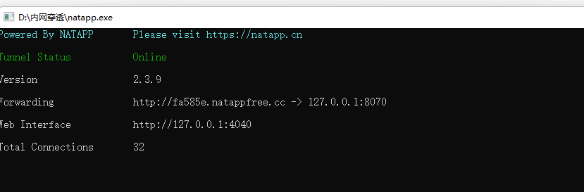

启动客户端后http://fa585e.natappfree.cc/xxx 的请求会映射到 http://localhost:8070/xxx。

# 第3章 数仓开发之ADS层

## 3.1 流量主题

### 3.1.1 各来源流量统计

**1）需求说明**

|  |  |  |  |
| --- | --- | --- | --- |
| 统计周期 | 统计粒度 | 指标 | 说明 |
| 当日 | 来源 | 独立访客数 | 统计访问人数 |
| 当日 | 来源 | 会话总数 | 统计会话总数 |
| 当日 | 来源 | 会话平均浏览页面数 | 统计每个会话平均浏览页面数 |
| 当日 | 来源 | 会话平均停留时长 | 统计每个会话平均停留时长 |
| 当日 | 来源 | 跳出率 | 只有一个页面的会话的比例 |

**2）需求分析**

柱状图可以直观展示不同渠道的度量值，本节将为上述五个指标各生成一张柱状图。

**3）数据结构**

图表所需数据结构的获取详见本节 **7）Sugar 配置**。

{

"status": 0,

"msg": "",

"data": {

"categories": [

"Appstore",

"xiaomi",

...

],

"series": [

{

"name": "独立访客数",

"data": [

"99",

"74",

...

]

}

]

}

}

（1）categories

数组中存储的元素为柱状图横轴所有取值。

（2）data

数组中存储的元素为与横轴对应的纵轴取值。

**4）Mapper 层**

（1）实体类

① TrafficUvCt

package com.atguigu.edu.publisher.bean;

import lombok.AllArgsConstructor;

import lombok.Data;

@Data

@AllArgsConstructor

public class TrafficUvCt {

// 来源

String source_name;

// 独立访客数

Long uv_count;

}

② TrafficSvCt

package com.atguigu.edu.publisher.bean;

import lombok.AllArgsConstructor;

import lombok.Data;

@Data

@AllArgsConstructor

public class TrafficSvCt {

// 来源

String source_name;

// 会话数

Long total_session_count;

}

③ TrafficPvPerSession

package com.atguigu.edu.publisher.bean;

import lombok.AllArgsConstructor;

import lombok.Data;

@Data

@AllArgsConstructor

public class TrafficPvPerSession {

// 来源

String source_name;

// 各会话页面浏览数

Double page_view_count;

}

④ TrafficDurPerSession

package com.atguigu.edu.publisher.bean;

import lombok.AllArgsConstructor;

import lombok.Data;

@Data

@AllArgsConstructor

public class TrafficDurPerSession {

// 来源

String source_name;

// 各会话页面停留时长

Double total_during_sec;

}

⑤ TrafficUjRate

package com.atguigu.edu.publisher.bean;

import lombok.AllArgsConstructor;

import lombok.Data;

@Data

@AllArgsConstructor

public class TrafficUjRate {

// 来源

String source_name;

// 跳出会话数

Double jump_session_count;

}

（2）Mapper 接口

package com.atguigu.edu.publisher.mapper;

import com.atguigu.edu.publisher.bean.*;

import org.apache.ibatis.annotations.Param;

import org.apache.ibatis.annotations.Select;

import java.util.List;

public interface TrafficSourceStatsMapper {

**// 1. 获取各来源独立访客数**

@Select("select source_name,\n" +

" sum(uv_count) uv_count\n" +

"from dws_traffic_vc_source_ar_is_new_page_view_window\n" +

"where toYYYYMMDD(stt) = #{date}\n" +

"group by toYYYYMMDD(stt), source_id, source_name\n" +

"order by uv_count desc;")

List<TrafficUvCt> selectUvCt(@Param("date") Integer date);

**// 2. 获取各来源会话数**

@Select("select source_name,\n" +

" sum(total_session_count) total_session_count\n" +

"from dws_traffic_vc_source_ar_is_new_page_view_window\n" +

"where toYYYYMMDD(stt) = #{date}\n" +

"group by toYYYYMMDD(stt), source_id, source_name\n" +

"order by total_session_count desc;")

List<TrafficSvCt> selectSvCt(@Param("date") Integer date);

**// 3. 获取各来源会话平均页面浏览数**

@Select("select source_name,\n" +

" sum(page_view_count) / sum(total_session_count) pv_per_session\n" +

"from dws_traffic_vc_source_ar_is_new_page_view_window\n" +

"where toYYYYMMDD(stt) = #{date}\n" +

"group by toYYYYMMDD(stt), source_id, source_name\n" +

"order by pv_per_session desc;")

List<TrafficPvPerSession> selectPvPerSession(@Param("date") Integer date);

**// 4. 获取各来源会话平均页面访问时长**

@Select("select source_name,\n" +

" sum(total_during_time) / sum(total_session_count) dur_per_session\n" +

"from dws_traffic_vc_source_ar_is_new_page_view_window\n" +

"where toYYYYMMDD(stt) = #{date}\n" +

"group by toYYYYMMDD(stt), source_id, source_name\n" +

"order by dur_per_session desc;")

List<TrafficDurPerSession> selectDurPerSession(@Param("date") Integer date);

**// 5. 获取各来源跳出率**

@Select("select source_name,\n" +

" sum(jump_session_count) / sum(total_session_count) uj_rate\n" +

"from dws_traffic_vc_source_ar_is_new_page_view_window\n" +

"where toYYYYMMDD(stt) = #{date}\n" +

"group by toYYYYMMDD(stt), source_id, source_name\n" +

"order by uj_rate desc;")

List<TrafficUjRate> selectUjRate(@Param("date") Integer date);

}

（3）注解

① @Select 注解

位于方法定义语句上方，修饰方法。

添加该注解后， Mybatis 会自动实现 JDBC 的环境准备，实现对应的 Mapper 层接口，并在 Tomcat 容器启动时将该实现类加载到容器中，包含 @Service 注解的功能。可以在服务层的 Impl 类中通过 @Autowired 自动装载该实现类。该实现类是单例的。

注意：要将该类加载到容器中，需要在启动类上方添加 @MapperScan 注解，指明 mapper 包路径，如下。

package com.atguigu.edu.publisher;

import org.mybatis.spring.annotation.MapperScan;

import org.springframework.boot.SpringApplication;

import org.springframework.boot.autoconfigure.SpringBootApplication;

@SpringBootApplication

**@MapperScan(basePackages = "com.atguigu.edu.publisher.mapper")**

public class EduRealtimePublisher {

public static void main(String[] args) {

SpringApplication.run(EduRealtimePublisher.class, args);

}

}

② @Param 注解

位于方法参数数据类型之前，修饰参数。

该注解可以将方法参数接收的值赋给注解参数中的变量，该变量可以在方法上方 @Select 注解的 SQL 语句中使用，调用方式为 #{变量名}。

如 @Param("paramDate")Integer date，将参数 date 接收到的数据赋值给 paramDate，可以在 SQL 中通过 #{paramDate} 获取 paramDate 参数的值。

**5）Service 层**

（1）service 接口

package com.atguigu.edu.publisher.service;

import com.atguigu.edu.publisher.bean.*;

import java.util.List;

public interface TrafficSourceStatsService {

**// 1. 获取各来源独立访客数**

List<TrafficUvCt> getUvCt(Integer date);

**// 2. 获取各来源会话数**

List<TrafficSvCt> getSvCt(Integer date);

**// 3. 获取各来源会话平均页面浏览数**

List<TrafficPvPerSession> getPvPerSession(Integer date);

**// 4. 获取各来源会话平均页面访问时长**

List<TrafficDurPerSession> getDurPerSession(Integer date);

**// 5. 获取各来源跳出率**

List<TrafficUjRate> getUjRate(Integer date);

}

（2）service 实现类

package com.atguigu.edu.publisher.service.impl;

import com.atguigu.edu.publisher.bean.*;

import com.atguigu.edu.publisher.mapper.TrafficSourceStatsMapper;

import com.atguigu.edu.publisher.service.TrafficSourceStatsService;

import org.springframework.beans.factory.annotation.Autowired;

import org.springframework.stereotype.Service;

import java.util.List;

@Service

public class TrafficSourceStatsServiceImpl implements TrafficSourceStatsService {

**// 自动装载 Mapper 接口实现类**

@Autowired

TrafficSourceStatsMapper trafficSourceStatsMapper;

**// 1. 获取各来源独立访客数**

@Override

public List<TrafficUvCt> getUvCt(Integer date) {

return trafficSourceStatsMapper.selectUvCt(date);

}

**// 2. 获取各来源会话数**

@Override

public List<TrafficSvCt> getSvCt(Integer date) {

return trafficSourceStatsMapper.selectSvCt(date);

}

**// 3. 获取各来源会话平均页面浏览数**

@Override

public List<TrafficPvPerSession> getPvPerSession(Integer date) {

return trafficSourceStatsMapper.selectPvPerSession(date);

}

**// 4. 获取各来源会话平均页面访问时长**

@Override

public List<TrafficDurPerSession> getDurPerSession(Integer date) {

return trafficSourceStatsMapper.selectDurPerSession(date);

}

**// 5. 获取各来源跳出率**

@Override

public List<TrafficUjRate> getUjRate(Integer date) {

return trafficSourceStatsMapper.selectUjRate(date);

}

}

（3）注解

① @Service 注解

位于实现类定义语句上方，修饰类。

把该实现类注册成一个组件，这个组件常驻内存，而且默认为单态（即单例，整个服务器进程，该类对象只有一个）。启动时会扫描所有被 @Service 注解修饰的实现类，将它们加载到内存。

② @Autowired 注解

位于成员变量（属性）定义语句上方，修饰类的属性。

① 控制器组件会扫描接口名上方添加了 @Autowired（自动装配）注解的接口，然后去内存的常驻组件中寻找适配组件（实现类），令此处的引用指向适配组件。

② 如果一个接口有多个实现类注册成为了组件，可以通过 @ Qualifier("组件名称") 注解指定不同的适配组件。此处的组件名称在 @Service 注解的参数中指定，如 @Service("组件名称")，只有一个实现类时可以不起名（不传参），直接使用 @Service 注解。

**6）controller 层**

（1）代码

package com.atguigu.edu.publisher.controller;

import com.atguigu.edu.publisher.bean.*;

import com.atguigu.edu.publisher.service.TrafficKeywordsService;

import com.atguigu.edu.publisher.service.TrafficSourceStatsService;

import com.atguigu.edu.publisher.service.TrafficVisitorStatsService;

import com.atguigu.edu.publisher.util.DateUtil;

import org.apache.commons.lang3.StringUtils;

import org.springframework.beans.factory.annotation.Autowired;

import org.springframework.web.bind.annotation.RequestMapping;

import org.springframework.web.bind.annotation.RequestParam;

import org.springframework.web.bind.annotation.RestController;

import java.util.List;

@RestController

@RequestMapping("/edu/realtime/traffic")

public class TrafficController {

// 自动装载来源流量统计服务实现类

@Autowired

private TrafficSourceStatsService trafficSourceStatsService;

**// 1. 独立访客请求拦截方法**

@RequestMapping("/uvCt")

public String getUvCt(

@RequestParam(value = "date", defaultValue = "1") Integer date) {

if (date == 1) {

date = DateUtil.now();

}

List<TrafficUvCt> trafficUvCtList = trafficSourceStatsService.getUvCt(date);

if (trafficUvCtList == null || trafficUvCtList.size() == 0) {

return "";

}

StringBuilder categories = new StringBuilder("[");

StringBuilder uvCtValues = new StringBuilder("[");

for (int i = 0; i < trafficUvCtList.size(); i++) {

TrafficUvCt trafficUvCt = trafficUvCtList.get(i);

String source_name = trafficUvCt.getSource_name();

Long uvCt = trafficUvCt.getUv_count();

categories.append("\"").append(source_name).append("\"");

uvCtValues.append("\"").append(uvCt).append("\"");

if (i < trafficUvCtList.size() - 1) {

categories.append(",");

uvCtValues.append(",");

} else {

categories.append("]");

uvCtValues.append("]");

}

}

return "{\n" +

" \"status\": 0,\n" +

" \"msg\": \"\",\n" +

" \"data\": {\n" +

" \"categories\":" + categories + ",\n" +

" \"series\": [\n" +

" {\n" +

" \"name\": \"独立访客数\",\n" +

" \"data\": " + uvCtValues + "\n" +

" }\n" +

" ]\n" +

" }\n" +

"}";

}

**// 2. 会话数请求拦截方法**

@RequestMapping("/svCt")

public String getPvCt(

@RequestParam(value = "date", defaultValue = "1") Integer date) {

if (date == 1) {

date = DateUtil.now();

}

List<TrafficSvCt> trafficSvCtList = trafficSourceStatsService.getSvCt(date);

if (trafficSvCtList == null) {

return "";

}

StringBuilder categories = new StringBuilder("[");

StringBuilder svCtValues = new StringBuilder("[");

for (int i = 0; i < trafficSvCtList.size(); i++) {

TrafficSvCt trafficSvCt = trafficSvCtList.get(i);

String source_name = trafficSvCt.getSource_name();

Long svCt = trafficSvCt.getTotal_session_count();

categories.append("\"").append(source_name).append("\"");

svCtValues.append("\"").append(svCt).append("\"");

if (i < trafficSvCtList.size() - 1) {

categories.append(",");

svCtValues.append(",");

} else {

categories.append("]");

svCtValues.append("]");

}

}

return "{\n" +

" \"status\": 0,\n" +

" \"msg\": \"\",\n" +

" \"data\": {\n" +

" \"categories\":" + categories + ",\n" +

" \"series\": [\n" +

" {\n" +

" \"name\": \"会话数\",\n" +

" \"data\": " + svCtValues + "\n" +

" }\n" +

" ]\n" +

" }\n" +

"}";

}

**// 3. 各会话浏览页面数请求拦截方法**

@RequestMapping("/pvPerSession")

public String getPvPerSession(

@RequestParam(value = "date", defaultValue = "1") Integer date) {

if (date == 1) {

date = DateUtil.now();

}

List<TrafficPvPerSession> trafficPvPerSessionList = trafficSourceStatsService.getPvPerSession(date);

if (trafficPvPerSessionList == null) {

return "";

}

StringBuilder categories = new StringBuilder("[");

StringBuilder pvPerSessionValues = new StringBuilder("[");

for (int i = 0; i < trafficPvPerSessionList.size(); i++) {

TrafficPvPerSession trafficPvPerSession = trafficPvPerSessionList.get(i);

String source_name = trafficPvPerSession.getSource_name();

Double pvPerSession = trafficPvPerSession.getPage_view_count();

categories.append("\"").append(source_name).append("\"");

pvPerSessionValues.append("\"").append(pvPerSession).append("\"");

if (i < trafficPvPerSessionList.size() - 1) {

categories.append(",");

pvPerSessionValues.append(",");

} else {

categories.append("]");

pvPerSessionValues.append("]");

}

}

return "{\n" +

" \"status\": 0,\n" +

" \"msg\": \"\",\n" +

" \"data\": {\n" +

" \"categories\":" + categories + ",\n" +

" \"series\": [\n" +

" {\n" +

" \"name\": \"会话平均页面浏览数\",\n" +

" \"data\": " + pvPerSessionValues + "\n" +

" }\n" +

" ]\n" +

" }\n" +

"}";

}

**// 4. 各会话累计访问时长请求拦截方法**

@RequestMapping("/durPerSession")

public String getDurPerSession(

@RequestParam(value = "date", defaultValue = "1") Integer date) {

if (date == 1) {

date = DateUtil.now();

}

List<TrafficDurPerSession> trafficDurPerSessionList = trafficSourceStatsService.getDurPerSession(date);

if (trafficDurPerSessionList == null) {

return "";

}

StringBuilder categories = new StringBuilder("[");

StringBuilder durPerSessionValues = new StringBuilder("[");

for (int i = 0; i < trafficDurPerSessionList.size(); i++) {

TrafficDurPerSession trafficDurPerSession = trafficDurPerSessionList.get(i);

String source_name = trafficDurPerSession.getSource_name();

Double durPerSession = trafficDurPerSession.getTotal_during_sec();

categories.append("\"").append(source_name).append("\"");

durPerSessionValues.append("\"").append(durPerSession).append("\"");

if (i < trafficDurPerSessionList.size() - 1) {

categories.append(",");

durPerSessionValues.append(",");

} else {

categories.append("]");

durPerSessionValues.append("]");

}

}

return "{\n" +

" \"status\": 0,\n" +

" \"msg\": \"\",\n" +

" \"data\": {\n" +

" \"categories\":" + categories + ",\n" +

" \"series\": [\n" +

" {\n" +

" \"name\": \"会话平均页面浏览数\",\n" +

" \"data\":" + durPerSessionValues + "\n" +

" }\n" +

" ]\n" +

" }\n" +

"}";

}

**// 5. 跳出率请求拦截方法**

@RequestMapping("/ujRate")

public String getUjRate(

@RequestParam(value = "date", defaultValue = "1") Integer date) {

if (date == 1) {

date = DateUtil.now();

}

List<TrafficUjRate> trafficUjRateList = trafficSourceStatsService.getUjRate(date);

if (trafficUjRateList == null) {

return "";

}

StringBuilder categories = new StringBuilder("[");

StringBuilder ujRateValues = new StringBuilder("[");

for (int i = 0; i < trafficUjRateList.size(); i++) {

TrafficUjRate trafficUjRate = trafficUjRateList.get(i);

String source_name = trafficUjRate.getSource_name();

Double ujRate = trafficUjRate.getJump_session_count();

categories.append("\"").append(source_name).append("\"");

ujRateValues.append("\"").append(ujRate).append("\"");

if (i < trafficUjRateList.size() - 1) {

categories.append(",");

ujRateValues.append(",");

} else {

categories.append("]");

ujRateValues.append("]");

}

}

return "{\n" +

" \"status\": 0,\n" +

" \"msg\": \"\",\n" +

" \"data\": {\n" +

" \"categories\":" + categories + ",\n" +

" \"series\": [\n" +

" {\n" +

" \"name\": \"跳出率\",\n" +

" \"data\": " + ujRateValues + "\n" +

" }\n" +

" ]\n" +

" }\n" +

"}";

}

}

（2）注解

① @RestController

位于控制类定义语句上方，修饰控制类。

标注方法为控制类，可以将外部请求引入该类的方法中。当方法返回值类型为 String 时，不会发生页面跳转，相当于 @Controller + @ResponseBody。

② @RequestMapping

可以在控制类定义语句上方添加，也可以在方法定义语句上方添加。

示例：@RequestMapping(value = "/traffic", method = RequestMethod.GET)。

该注解用于建立请求URL和请求处理方法之间的对应关系。value 用于指定请求 URL。请求处理方法最终拦截的 URL为类注解指定的路径与方法注解指定的路径拼接所得的 URL。如当前 SpringBoot 服务占用了本机的 8080 端口，类上注解为 @RequestMapping("/gmall ")，方法上方注解为 @RequestMapping("/uvCt")，则最终拦截的 url 为 localhost:8070/gmall/uvCt。控制类上方可以没有该注解。

如果拦截的是 GET 请求，method 参数赋值语句可以省略。此外，SpringBoot 的注解只有一个参数，且参数名称为 value时，可以省略参数名称和等号。

所以，@RequestMapping(value = "/traffic", method = RequestMethod.GET) 可简写为 @RequestMapping("/traffic")。

该注解相当于 @GetMapping("/traffic")

③ @RequestParma("name")

位于方法参数数据类型之前。接收请求路径中键值对(名值对)的参数(通常用于查询条件、辅助参数) 并传递给所修饰的参数。

如 URL 为 localhost:8070/test?paramDt=20220221，注解为 @RequestParam("paramDt") Integer dt，则 20220221 会被解析为 Integer 类型数据赋值给 dt 参数。

**7）Sugar 配置**

（1）页面宏定义变量

单击大屏空白处，在右侧“控制面板”中点击“页面宏定义变量”，定义 EDU_HOST 和 EDU_DATE。

* + EDU_HOST：本地 8070 端口服务映射的公网域名。
  + EDU_DATE：当日日期。本项目的“当日”为模拟数据的业务日期。

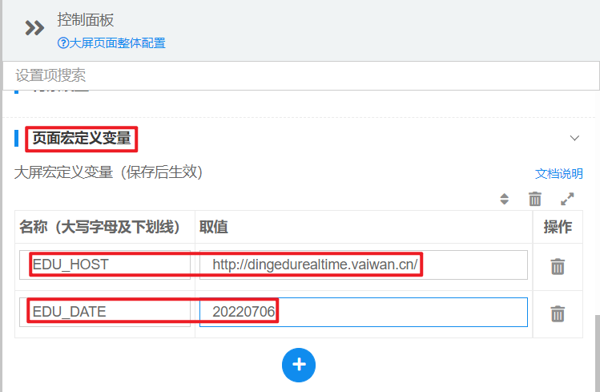

（2）在“图表”中选择“柱状图”

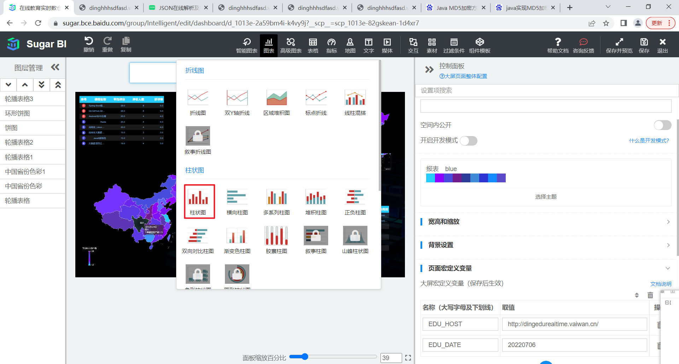

（3）在弹出的控制面板中选择 API 拉取

* + API 拉取：通过给定的数据接口获取数据。我们选择这种方式。
  + 静态 JSON：通过给定的静态 JSON 字符串获取数据。

API 拉取返回的数据格式与静态 JSON 相同，因此可以通过静态 JSON 的示例数据查看数据格式。

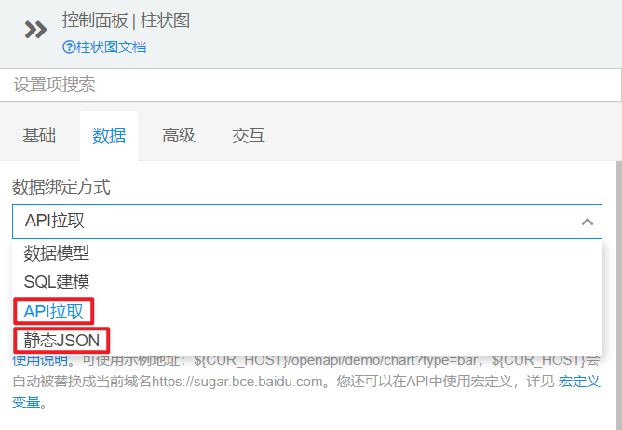

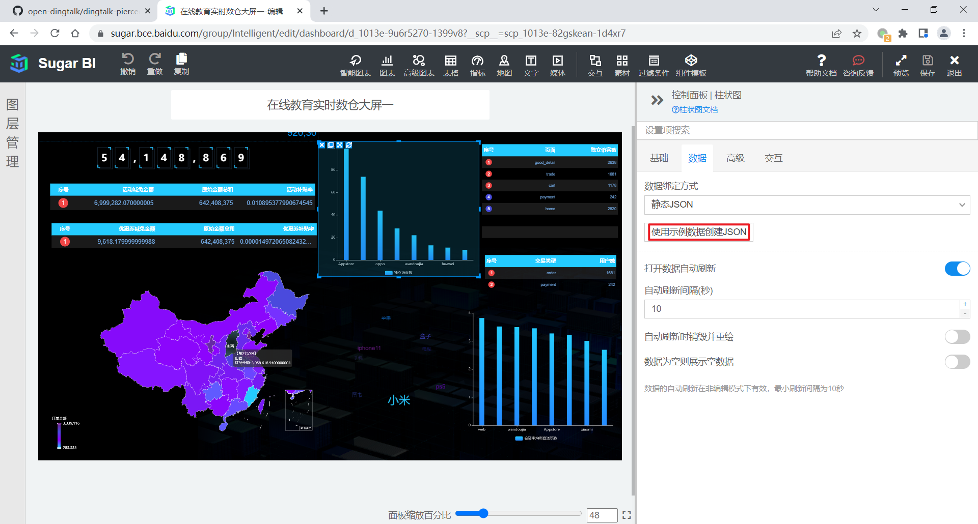

（4）输入数据接口的 URL

${EDU_HOST}/edu/realtime/traffic/uvCt?date=${EDU_DATE}

（5）刷新图表，查看效果

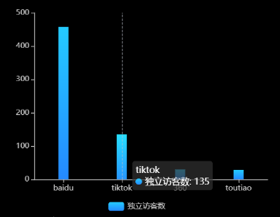

另外四张柱状图的配置同理，不再赘述。

所有图表的 URL 如下。

**# 独立访客**

${EDU_HOST}/edu/realtime/traffic/uvCt?date=${EDU_DATE}

**# 会话数**

${EDU_HOST}/edu/realtime/traffic/svCt?date=${EDU_DATE}

**# 会话平均页面浏览数**

${EDU_HOST}/edu/realtime/traffic/pvPerSession?date=${EDU_DATE}

**# 会话平均访问时长**

${EDU_HOST}/edu/realtime/traffic/durPerSession?date=${EDU_DATE}

**# 跳出率**

${EDU_HOST}/edu/realtime/traffic/ujRate?date=${EDU_DATE}

### 3.1.2 流量分时统计

**1）需求说明**

|  |  |  |
| --- | --- | --- |
| 统计周期 | 指标 | 说明 |
| 1 小时 | 独立访客数 | 统计当日各小时独立访客数 |
| 1 小时 | 页面浏览数 | 统计当日各小时页面浏览数 |
| 1 小时 | 新访客数 | 统计当日各小时新访客数 |

**2）需求分析**

本节统计分时指标，选用折线图进行展示。三个指标将体现在同一张折线图中。

**3）数据结构**

{

"status": 0,

"msg": "",

"data": {

"categories": [

"00",

"01",

...

],

"series": [

{

"name": "独立访客数",

"data": [

0,

300,

...

]

},

{

"name": "页面浏览数",

"data": [

0,

988,

...

]

},

{

"name": "新访客数",

"data": [

0,

155,

...

]

}

]

}

}

**4）Mapper 层**

（1）实体类

package com.atguigu.edu.publisher.bean;

import lombok.AllArgsConstructor;

import lombok.Data;

@Data

@AllArgsConstructor

public class TrafficVisitorStatsPerHour {

// 小时

Integer hr;

// 独立访客数

Long uv_count;

// 页面浏览数

Long page_view_count;

// 新访客数

Long newUvCt;

}

（2）Mapper 接口

package com.atguigu.edu.publisher.mapper;

import com.atguigu.edu.publisher.bean.TrafficVisitorStatsPerHour;

import com.atguigu.edu.publisher.bean.TrafficVisitorTypeStats;

import org.apache.ibatis.annotations.Param;

import org.apache.ibatis.annotations.Select;

import java.util.List;

public interface TrafficVisitorStatsMapper {

**// 分时流量数据查询**

@Select("select\n" +

"toHour(stt) hr,\n" +

"sum(uv_count) uv_count,\n" +

"sum(page_view_count) page_view_count,\n" +

"sum(if(is_new = '1', dws_traffic_vc_source_ar_is_new_page_view_window.uv_count, 0)) new_uv_ct\n" +

"from dws_traffic_vc_source_ar_is_new_page_view_window\n" +

"where toYYYYMMDD(stt) = #{date}\n" +

"group by hr")

List<TrafficVisitorStatsPerHour> selectVisitorStatsPerHr(Integer date);

}

**5）Service 层**

（1）Service 接口

package com.atguigu.edu.publisher.service;

import com.atguigu.edu.publisher.bean.TrafficVisitorStatsPerHour;

import com.atguigu.edu.publisher.bean.TrafficVisitorTypeStats;

import java.util.List;

public interface TrafficVisitorStatsService {

**// 获取分时流量数据**

List<TrafficVisitorStatsPerHour> getVisitorPerHrStats(Integer date);

}

（2）实现类

package com.atguigu.gmall.publisher.service.impl;

import com.atguigu.gmall.publisher.bean.TrafficVisitorStatsPerHour;

import com.atguigu.gmall.publisher.bean.TrafficVisitorTypeStats;

import com.atguigu.gmall.publisher.mapper.TrafficVisitorStatsMapper;

import com.atguigu.gmall.publisher.service.TrafficVisitorStatsService;

import org.springframework.beans.factory.annotation.Autowired;

import org.springframework.stereotype.Service;

import java.util.List;

@Service

public class TrafficVisitorStatsServiceImpl implements TrafficVisitorStatsService {

@Autowired

private TrafficVisitorStatsMapper trafficVisitorStatsMapper;

**// 获取分时流量统计数据**

@Override

public List<TrafficVisitorStatsPerHour> getVisitorPerHrStats(Integer date) {

return trafficVisitorStatsMapper.selectVisitorStatsPerHr(date);

}

}

**6）Controller 层**

在 TrafficController 类中补充成员变量和请求拦截方法。

**// 自动装载访客状态统计服务实现类**

@Autowired

private TrafficVisitorStatsService trafficVisitorStatsService;

**// 访客状态分时统计请求拦截方法**

@RequestMapping("/visitorPerHr")

public String getVisitorPerHr(

@RequestParam(value = "date", defaultValue = "1") Integer date) {

if (date == 1) {

date = DateUtil.now();

}

List<TrafficVisitorStatsPerHour> visitorPerHrStatsList = trafficVisitorStatsService.getVisitorPerHrStats(date);

if (visitorPerHrStatsList == null || visitorPerHrStatsList.size() == 0) {

return "";

}

TrafficVisitorStatsPerHour[] perHrArr = new TrafficVisitorStatsPerHour[24];

for (TrafficVisitorStatsPerHour trafficVisitorStatsPerHour : visitorPerHrStatsList) {

Integer hr = trafficVisitorStatsPerHour.getHr();

perHrArr[hr] = trafficVisitorStatsPerHour;

}

String[] hrs = new String[24];

Long[] uvArr = new Long[24];

Long[] pvArr = new Long[24];

Long[] newUvArr = new Long[24];

for (int hr = 0; hr < 24; hr++) {

hrs[hr] = String.format("%02d", hr);

TrafficVisitorStatsPerHour trafficVisitorStatsPerHour = perHrArr[hr];

if (trafficVisitorStatsPerHour != null) {

uvArr[hr] = trafficVisitorStatsPerHour.getUv_count();

pvArr[hr] = trafficVisitorStatsPerHour.getPage_view_count();

newUvArr[hr] = trafficVisitorStatsPerHour.getNewUvCt();

} else{

uvArr[hr] = 0L;

pvArr[hr] = 0L;

newUvArr[hr] = 0L;

}

}

return "{\n" +

" \"status\": 0,\n" +

" \"msg\": \"\",\n" +

" \"data\": {\n" +

" \"categories\": [\n\"" +

StringUtils.join(hrs, "\",\"") + "\"\n" +

" ],\n" +

" \"series\": [\n" +

" {\n" +

" \"name\": \"独立访客数\",\n" +

" \"data\": [\n" +

StringUtils.join(uvArr, ",") + "\n" +

" ]\n" +

" },\n" +

" {\n" +

" \"name\": \"页面浏览数\",\n" +

" \"data\": [\n" +

StringUtils.join(pvArr, ",") + "\n" +

" ]\n" +

" },\n" +

" {\n" +

" \"name\": \"新访客数\",\n" +

" \"data\": [\n" +

StringUtils.join(newUvArr, ",") + "\n" +

" ]\n" +

" }\n" +

" ]\n" +

" }\n" +

"}";

}

**7）Sugar 配置**

① 选择折线图。

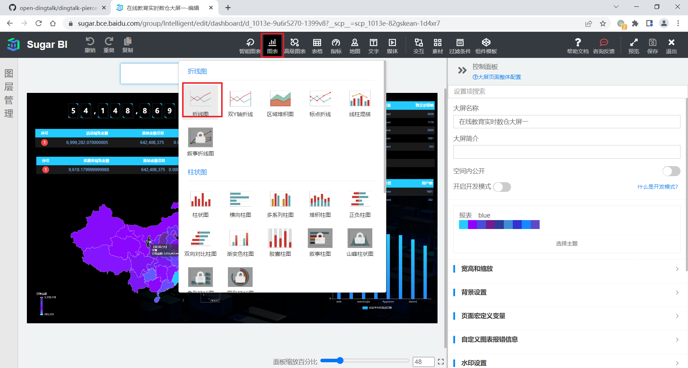

② 数据绑定方式为 “API 拉取”，输入数据接口的 URL，如下。

${EDU_HOST}/edu/realtime/traffic/visitorPerHr?date=${EDU_DATE}

③ 效果如下。

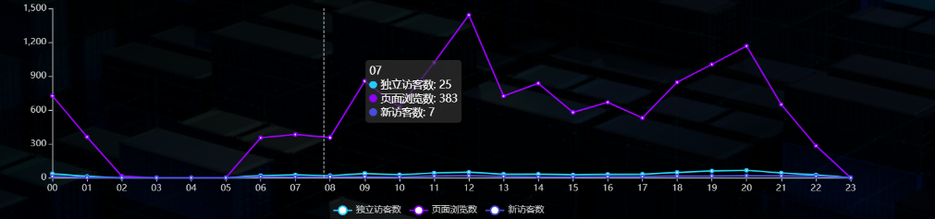

### 3.1.3 新老访客流量统计

**1）需求介绍**

|  |  |  |  |
| --- | --- | --- | --- |
| 统计周期 | 统计粒度 | 指标 | 说明 |
| 当日 | 访客类型 | 独立访客数 | 分别统计新老访客数 |
| 当日 | 访客类型 | 页面浏览数 | 分别统计新老访客页面浏览数 |
| 当日 | 访客类型 | 跳出率 | 分别统计新老访客跳出率 |
| 当日 | 访客类型 | 平均在线时长 | 分别统计新老访客平均在线时长 |
| 当日 | 访客类型 | 平均访问页面数 | 分别统计新老访客平均访问页面数 |

**2）需求分析**

本节将通过表格对数据进行展示。所有指标将在同一张表格中体现。

**3）数据结构**

{

"status": 0,

"data": {

"total": 5,

"columns": [

{

"name": "类别",

"id": "type"

},

{

"name": "新访客",

"id": "new"

},

{

"name": "老访客",

"id": "old"

}

],

"rows": [

{

"type": "访客数(人)",

"new": 155,

"old": 145

},

{

"type": "总访问页面数(次)",

"new": 507,

"old": 481

},

{

"type": "跳出率(%)",

"new": 0,

"old": 0

},

{

"type": "平均在线时长(秒)",

"new": 33.659716129032255,

"old": 35.37985517241379

},

{

"type": "平均访问页面数(人次)",

"new": 3.270967741935484,

"old": 3.317241379310345

}

]

}

}

**4）Mapper 层**

（1）实体类

package com.atguigu.edu.publisher.bean;

import lombok.AllArgsConstructor;

import lombok.Data;

@Data

@AllArgsConstructor

public class TrafficVisitorTypeStats {

// 新老访客状态标记

String isNew;

// 独立访客数

Long uv_count;

// 页面浏览数

Long page_view_count;

// 会话数

Long total_session_count;

// 跳出会话数

Long jump_session_count;

// 累计访问时长

Long total_during_time;

// 跳出率

public Double getUjRate() {

if (total_session_count == 0) {

return 0.0;

}

return (double) jump_session_count / (double) total_session_count;

}

// 会话平均在线时长（秒）

public Double getAvgDurSum() {

if (total_session_count == 0) {

return 0.0;

}

return (double) total_during_time / (double) total_session_count / 1000;

}

// 会话平均访问页面数

public Double getAvgPvCt() {

if (total_session_count == 0) {

return 0.0;

}

return (double) page_view_count / (double) total_session_count;

}

}

（2）Mapper 接口

在 TrafficVisitorStatsMapper 接口中补充方法。

**// 各类访客流量数据查询**

@Select("select\n" +

"is_new,\n" +

"sum(uv_count) uv_count,\n" +

"sum(page_view_count) page_view_count,\n" +

"sum(total_session_count) total_session_count,\n" +

"sum(jump_session_count) jump_session_count,\n" +

"sum(total_during_time) total_during_time\n" +

"from dws_traffic_vc_source_ar_is_new_page_view_window\n" +

"where toYYYYMMDD(stt) =#{date}\n" +

"group by is_new")

List<TrafficVisitorTypeStats> selectVisitorTypeStats(@Param("date")Integer date);

**5）Service 层**

（1）Service 接口

在 TrafficVisitorStatsService 接口中补充方法。

**// 获取新老访客流量数据**

List<TrafficVisitorTypeStats> getVisitorTypeStats(Integer date);

（2）Service 实现类

在 TrafficVisitorStatsServiceImpl 实现类中补充 getVisitorTypeStats 方法的实现，

@Override

public List<TrafficVisitorTypeStats> getVisitorTypeStats(Integer date) {

return trafficVisitorStatsMapper.selectVisitorTypeStats(date);

}

**6）Controller 层**

在 TrafficController 类中补充请求拦截方法。

// 各类访客流量统计请求拦截方法

@RequestMapping("/visitorPerType")

public String getVisitorPerType(

@RequestParam(value = "date", defaultValue = "1") Integer date) {

if (date == 1) {

date = DateUtil.now();

}

List<TrafficVisitorTypeStats> visitorTypeStatsList = trafficVisitorStatsService.getVisitorTypeStats(date);

if (visitorTypeStatsList == null || visitorTypeStatsList.size() == 0) {

return "";

}

// 方法一：通过循环的方式拼接字符串，较为繁琐，不推荐

// StringBuilder columns = new StringBuilder("[\n" +

// " {\n" +

// " \"name\": \"指标\",\n" +

// " \"id\": \"indicators\"\n" +

// " },");

//

// StringBuilder uvRow = new StringBuilder("{\n" +

// " \"indicators\": \"独立访客数\",\n");

//

// StringBuilder pvRow = new StringBuilder("{\n" +

// " \"indicators\": \"页面浏览数\",\n");

//

// StringBuilder ujRow = new StringBuilder("{\n" +

// " \"indicators\": \"跳出率\",\n");

//

// StringBuilder avgDurRow = new StringBuilder("{\n" +

// " \"indicators\": \"会话平均访问时长\",\n");

//

// StringBuilder avgPvRow = new StringBuilder("{\n" +

// " \"indicators\": \"会话平均页面浏览数\",\n");

//

// for (int i = 0; i < visitorTypeStatsList.size(); i++) {

// TrafficVisitorTypeStats trafficVisitorTypeStats = visitorTypeStatsList.get(i);

// String isNew = trafficVisitorTypeStats.getIsNew();

// Integer uvCt = trafficVisitorTypeStats.getUvCt();

// Integer pvCt = trafficVisitorTypeStats.getPvCt();

// Double ujRate = trafficVisitorTypeStats.getUjRate();

// Double avgDurSum = trafficVisitorTypeStats.getAvgDurSum();

// Double avgPvCt = trafficVisitorTypeStats.getAvgPvCt();

// if (isNew.equals("1")) {

// columns.append("{\n" +

// " \"name\": \"新访客\",\n" +

// " \"id\": \"newVisitor\"\n" +

// " }");

// uvRow.append("\"newVisitor\": " + uvCt);

// pvRow.append("\"newVisitor\": " + pvCt);

// ujRow.append("\"newVisitor\": " + ujRate);

// avgDurRow.append("\"newVisitor\": " + avgDurSum);

// avgPvRow.append("\"newVisitor\": " + avgPvCt);

// } else {

// columns.append("{\n" +

// " \"name\": \"老访客\",\n" +

// " \"id\": \"oldVisitor\"\n" +

// " }");

//

// uvRow.append("\"oldVisitor\": " + uvCt + "\n");

// pvRow.append("\"oldVisitor\": " + pvCt + "\n");

// ujRow.append("\"oldVisitor\": " + ujRate + "\n");

// avgDurRow.append("\"oldVisitor\": " + avgDurSum + "\n");

// avgPvRow.append("\"oldVisitor\": " + avgPvCt + "\n");

// }

// if (i == 0) {

// columns.append(",\n");

// uvRow.append(",\n");

// pvRow.append(",\n");

// ujRow.append(",\n");

// avgDurRow.append(",\n");

// avgPvRow.append(",\n");

// } else {

// columns.append("\n]");

// uvRow.append("\n}");

// pvRow.append("\n}");

// ujRow.append("\n}");

// avgDurRow.append("\n}");

// avgPvRow.append("\n}");

// }

// }

// return "{\n" +

// " \"status\": 0,\n" +

// " \"msg\": \"\",\n" +

// " \"data\": {\n" +

// " \"columns\": "+ columns +",\n" +

// " \"rows\": [\n" +

// " "+ uvRow +",\n" +

// " "+ pvRow +",\n" +

// " "+ ujRow +",\n" +

// " "+ avgDurRow +",\n" +

// " "+ avgPvRow +"\n" +

// " ]\n" +

// " }\n" +

// "}";

// 方法二，直接拼接字符串，简单明了

TrafficVisitorTypeStats newVisitorStats = null;

TrafficVisitorTypeStats oldVisitorStats = null;

for (TrafficVisitorTypeStats visitorStats : visitorTypeStatsList) {

// System.out.println(visitorStats);

if ("1".equals(visitorStats.getIsNew())) {

// 新访客

newVisitorStats = visitorStats;

} else {

// 老访客

oldVisitorStats = visitorStats;

}

}

//拼接json字符串

String json = "{\"status\":0,\"data\":{\"total\":5," +

"\"columns\":[" +

"{\"name\":\"类别\",\"id\":\"type\"}," +

"{\"name\":\"新访客\",\"id\":\"new\"}," +

"{\"name\":\"老访客\",\"id\":\"old\"}]," +

"\"rows\":[" +

"{\"type\":\"访客数(人)\",\"new\":" + newVisitorStats.getUv_count() + ",\"old\":" + oldVisitorStats.getUv_count() + "}," +

"{\"type\":\"总访问页面数(次)\",\"new\":" + newVisitorStats.getPage_view_count() + ",\"old\":" + oldVisitorStats.getPage_view_count() + "}," +

"{\"type\":\"跳出率(%)\",\"new\":" + newVisitorStats.getUjRate() + ",\"old\":" + oldVisitorStats.getUjRate() + "}," +

"{\"type\":\"平均在线时长(秒)\",\"new\":" + newVisitorStats.getAvgDurSum() + ",\"old\":" + oldVisitorStats.getAvgDurSum() + "}," +

"{\"type\":\"平均访问页面数(人次)\",\"new\":" + newVisitorStats.getAvgPvCt() + ",\"old\":" + oldVisitorStats.getAvgPvCt() + "}]}}";

return json;

}

**7）Sugar 配置**

① 选择表格。

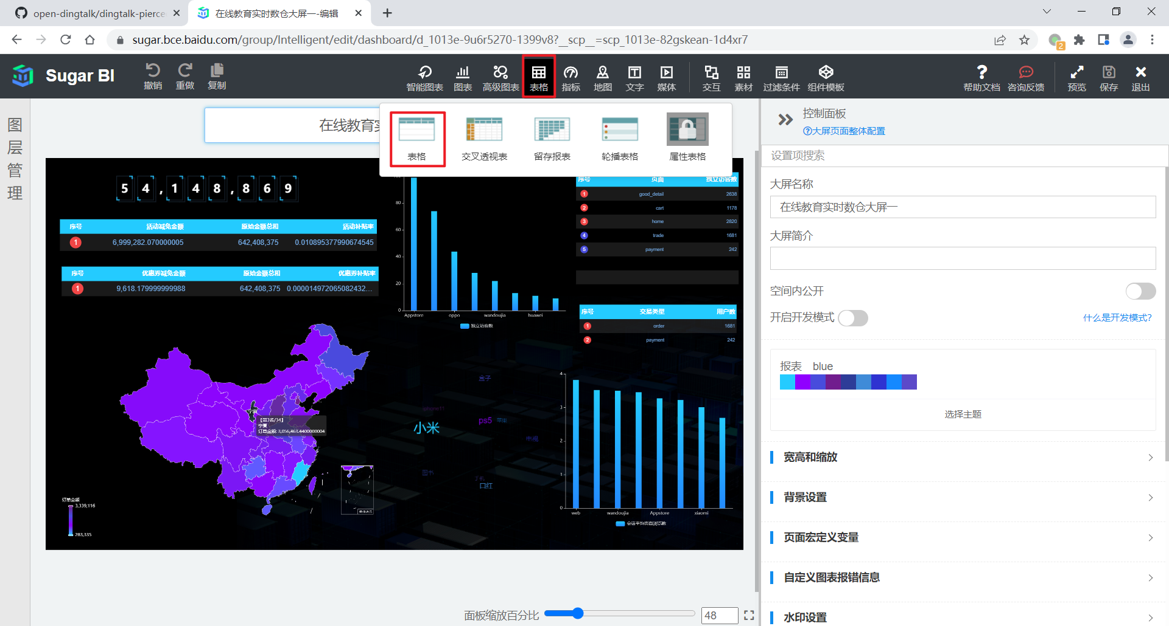

② 数据绑定方式为 “API 拉取”，输入数据接口的 URL，如下。

${EDU_HOST}/edu/realtime/traffic/visitorPerType?date=${EDU_DATE}

③ 效果如下。

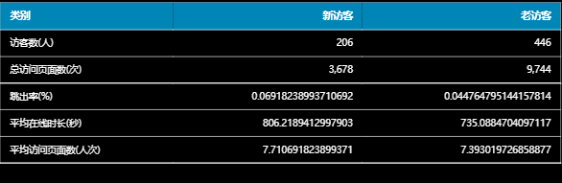

### 3.1.4 关键词统计

**1）需求介绍**

|  |  |  |  |
| --- | --- | --- | --- |
| 统计周期 | 统计粒度 | 指标 | 说明 |
| 当日 | 关键词 | 关键词评分 | 根据不同来源和频次计算得分 |

**2）需求分析**

关键词的展示使用 3D 词云实现。

**3）数据结构**

{

"status": 0,

"msg": "",

"data": [

{

"name": "小米",

"value": 2370

},

{

"name": "ps5",

"value": 1290

},

...

]

}

**4）Mapper 层**

（1）实体类

package com.atguigu.edu.publisher.bean;

import lombok.AllArgsConstructor;

import lombok.Data;

@Data

@AllArgsConstructor

public class TrafficKeywords {

// 关键词

String keyword;

// 关键词评分

Integer keywordScore;

}

（2）Mapper 接口

package com.atguigu.edu.publisher.mapper;

import com.atguigu.edu.publisher.bean.TrafficKeywords;

import org.apache.ibatis.annotations.Param;

import org.apache.ibatis.annotations.Select;

import java.util.List;

public interface TrafficKeywordsMapper {

@Select("select keyword,\n" +

" sum(keyword_count * multiIf(\n" +

" source = 'SEARCH', 10,\n" +

" source = 'ORDER', 5,\n" +

" source = 'CART', 2,\n" +

" source = 'CLICK', 1, 0\n" +

" )) keyword_score\n" +

"from dws_traffic_source_keyword_page_view_window\n" +

"where toYYYYMMDD(stt) = #{date}\n" +

"group by toYYYYMMDD(stt), keyword\n" +

"order by keyword_score desc;")

List<TrafficKeywords> selectKeywords(@Param(value = "date") Integer date);

}

**5）Service 层**

（1）Service 接口

package com.atguigu.edu.publisher.service;

import com.atguigu.edu.publisher.bean.TrafficKeywords;

import java.util.List;

public interface TrafficKeywordsService {

List<TrafficKeywords> getKeywords(Integer date);

}

（2）Service 实现类

package com.atguigu.edu.publisher.service.impl;

import com.atguigu.edu.publisher.mapper.TrafficKeywordsMapper;

import com.atguigu.edu.publisher.service.TrafficKeywordsService;

import com.atguigu.edu.publisher.bean.TrafficKeywords;

import org.springframework.beans.factory.annotation.Autowired;

import org.springframework.stereotype.Service;

import java.util.List;

@Service

public class TrafficKeywordsServiceImpl implements TrafficKeywordsService {

@Autowired

TrafficKeywordsMapper trafficKeywordsMapper;

@Override

public List<TrafficKeywords> getKeywords(Integer date) {

return trafficKeywordsMapper.selectKeywords(date);

}

}

**6）Controller 层**

在 TrafficController 中补充关键词服务接口类型成员变量和请求拦截方法。

**// 自动装载关键词统计服务实现类**

@Autowired

private TrafficKeywordsService trafficKeywordsService;

**// 关键词评分统计请求拦截方法**

@RequestMapping("/keywords")

public String getKeywords(

@RequestParam(value = "date", defaultValue = "1") Integer date) {

if (date == 1) {

date = DateUtil.now();

}

List<TrafficKeywords> keywordsList = trafficKeywordsService.getKeywords(date);

if (keywordsList == null) {

return "";

}

StringBuilder data = new StringBuilder("[");

for (int i = 0; i < keywordsList.size(); i++) {

TrafficKeywords trafficKeywords = keywordsList.get(i);

String keyword = trafficKeywords.getKeyword();

Integer keywordScore = trafficKeywords.getKeywordScore();

data.append("" +

"{\n" +

" \"name\": \"" + keyword + "\",\n" +

" \"value\": " + keywordScore + "\n" +

" }");

if (i < keywordsList.size() - 1) {

data.append(",");

} else {

data.append("]");

}

}

return "{\n" +

" \"status\": 0,\n" +

" \"msg\": \"\",\n" +

" \"data\": " + data + "\n" +

"}";

}

**7）Sugar 配置**

① 选择 3D 词云

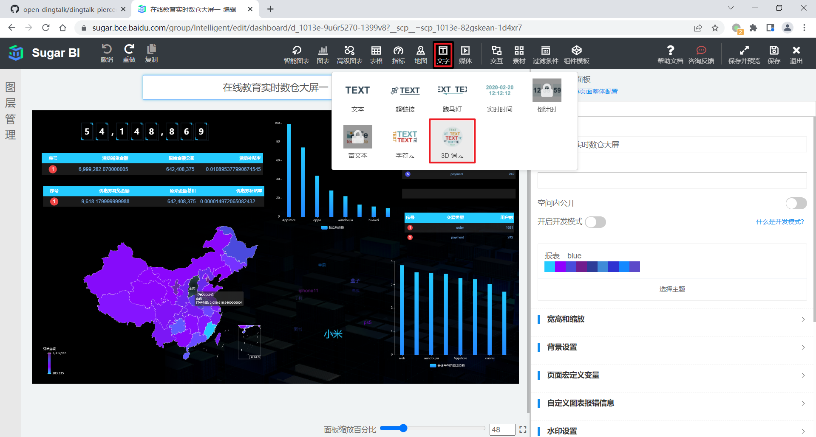

② 数据绑定方式为 “API 拉取”，输入数据接口的 URL，如下。

${EDU_HOST}/EDU/REALTIME/TRAFFIC/KEYWORDS?DATE=${EDU_DATE}

③ 效果如下



## 3.2 播放主题

### 3.2.1 各章节播放统计

**1）需求说明**

|  |  |  |  |
| --- | --- | --- | --- |
| 统计周期 | 统计粒度 | 指标 | 说明 |
| 当日 | 章节 | 视频播放次数 | 播放明细表中的一行为一次播放 |
| 当日 | 章节 | 累计播放时长 | 略 |
| 当日 | 章节 | 观看人数 | 略 |
| 当日 | 章节 | 人均观看时长 | 累计播放时长 / 观看人数 |

**2）需求分析**

本节指标使用轮播表格展示。

**3）数据结构**

略。

**4）Mapper 层**

（1）实体类

package com.atguigu.edu.publisher.bean;

import lombok.AllArgsConstructor;

import lombok.Data;

@Data

@AllArgsConstructor

public class VedioChapterStats {

//章节名称

String chapterName;

//播放次数

Integer playCT;

//播放时长

Double playTotalSec;

//观看人数

Integer uuCt;

//人均观看时长

Double secPerUser;

}

（2）Mapper 接口

package com.atguigu.edu.publisher.mapper;

import com.atguigu.edu.publisher.bean.VedioChapterStats;

import org.apache.ibatis.annotations.Param;

import org.apache.ibatis.annotations.Select;

import java.util.List;

public interface VideoChapterStatsMapper {

@Select("select chapter_name,\n" +

" sum(play_count) play_ct,\n" +

" sum(play_total_sec) play_total_sc,\n" +

" sum(play_uu_count) play_uu_ct,\n" +

" play_total_sc / play_uu_ct per_uu_sec\n" +

"from dws_learn_chapter_play_window\n" +

"where toYYYYMMDD(stt) = #{date}\n" +

"group by toYYYYMMDD(stt), chapter_name\n" +

"order by play_total_sc desc, play_ct desc, play_uu_ct desc\n" +

"limit 10;")

List<VedioChapterStats> selectVedioChapterStats(@Param("date")Integer date);

}

**5）Service 层**

（1）Service 接口

package com.atguigu.edu.publisher.service;

import com.atguigu.edu.publisher.bean.VedioChapterStats;

import java.util.List;

public interface VideoChapterStatsService {

List<VedioChapterStats> getVedioChapterStats(Integer date);

}

（2）Service 实现类

package com.atguigu.edu.publisher.service.impl;

import com.atguigu.edu.publisher.bean.VedioChapterStats;

import com.atguigu.edu.publisher.mapper.VideoChapterStatsMapper;

import com.atguigu.edu.publisher.service.VideoChapterStatsService;

import org.springframework.beans.factory.annotation.Autowired;

import org.springframework.stereotype.Service;

import java.util.List;

@Service

public class VideoChapterStatsServiceImpl implements VideoChapterStatsService {

@Autowired

VideoChapterStatsMapper videoChapterStatsMapper;

@Override

public List<VedioChapterStats> getVedioChapterStats(Integer date) {

return videoChapterStatsMapper.selectVedioChapterStats(date);

}

}

**6）Controller 层**

package com.atguigu.edu.publisher.controller;

import com.atguigu.edu.publisher.bean.VedioChapterStats;

import com.atguigu.edu.publisher.service.VideoChapterStatsService;

import com.atguigu.edu.publisher.util.DateUtil;

import org.springframework.beans.factory.annotation.Autowired;

import org.springframework.web.bind.annotation.RequestMapping;

import org.springframework.web.bind.annotation.RequestParam;

import org.springframework.web.bind.annotation.RestController;

import java.util.List;

@RestController

@RequestMapping("/edu/realtime/video")

public class VideoStatsController {

@Autowired

private VideoChapterStatsService videoChapterStatsService;

@RequestMapping("/playStatsPerChapter")

public String getVedioChapterStats(

@RequestParam(value = "date", defaultValue = "1") Integer date) {

if (date == 1) {

date = DateUtil.now();

}

List<VedioChapterStats> vedioChapterStatsList = videoChapterStatsService.getVedioChapterStats(date);

if (vedioChapterStatsList == null) {

return "";

}

StringBuilder rows = new StringBuilder("[");

for (int i = 0; i < vedioChapterStatsList .size(); i++) {

VedioChapterStats vedioChapterStats = vedioChapterStatsList.get(i);

String chapterName = vedioChapterStats.getChapterName();

Integer playCT = vedioChapterStats.getPlayCT();

Double playTotalSec = vedioChapterStats.getPlayTotalSec();

Integer uuCt = vedioChapterStats.getUuCt();

Double secPerUser = vedioChapterStats.getSecPerUser();

rows.append("{\n" +

"\t\"chapterName\": \"" + chapterName + "\",\n" +

"\t\"playCT\": \"" + playCT + "\",\n" +

"\t\"playTotalSec\": \"" + playTotalSec + "\",\n" +

"\t\"uuCt\": \"" + uuCt + "\",\n" +

"\t\"secPerUser\": \"" + secPerUser + "\"\n" +

"}");

if (i < vedioChapterStatsList.size() - 1) {

rows.append(",");

} else {

rows.append("]");

}

}

return "{\n" +

" \"status\": 0,\n" +

" \"msg\": \"\",\n" +

" \"data\": {\n" +

" \"columns\": [\n" +

" {\n" +

" \"name\": \"章节名称\",\n" +

" \"id\": \"chapterName\"\n" +

" },\n" +

" {\n" +

" \"name\": \"播放次数\",\n" +

" \"id\": \"playCT\"\n" +

" },\n" +

" {\n" +

" \"name\": \"播放时长\",\n" +

" \"id\": \"playTotalSec\"\n" +

" },\n" +

" {\n" +

" \"name\": \"观看人数\",\n" +

" \"id\": \"uuCt\"\n" +

" },\n" +

" {\n" +

" \"name\": \"人均观看时长\",\n" +

" \"id\": \"secPerUser\"\n" +

" }\n" +

" ],\n" +

" \"rows\": " + rows + "\n" +

" }\n" +

"}";

}

}

**7）Sugar 配置**

① 选择轮播表格，数据绑定方式为 “API 拉取”，输入数据接口的 URL，如下。

${EDU_HOST}/edu/realtime/video/playStatsPerChapter?date=${EDU_DATE}

② 效果如下

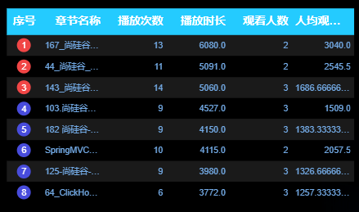

## 3.3 用户主题

### 3.3.1 用户变动统计

**1）需求介绍**

|  |  |  |
| --- | --- | --- |
| 统计周期 | 指标 | 说明 |
| 当日 | 回流用户数 | 之前的活跃用户，一段时间未活跃（流失），今日又活跃了，就称为回流用户。此处要求统计回流用户总数。 |

本节需求与 3.2.2 节需求合并展示。

### 3.3.2 用户新增活跃统计

**1）需求介绍**

需求说明如下

|  |  |  |
| --- | --- | --- |
| 统计周期 | 指标 | 指标说明 |
| 当日 | 新增用户数 | 略 |
| 当日 | 活跃用户数 | 略 |

**2）需求分析**

本节和 3.2.1 节指标展示将使用表格展示。

**3）数据结构**

{

"status": 0,

"msg": "",

"data": {

"columns": [

{

"name": "变动类型",

"id": "type"

},

{

"name": "用户数",

"id": "user_ct"

}

],

"rows": [

{

"type": "activeUserCt",

"user_ct": "915"

},

{

"type": "newUserCt",

"user_ct": "20"

},

{

"type": "backCt",

"user_ct": "0"

}

]

}

}

**4）Mapper 层**

（1）实体类

package com.atguigu.edu.publisher.bean;

import lombok.AllArgsConstructor;

import lombok.Data;

@Data

@AllArgsConstructor

public class UserChangeCtPerType {

// 变动类型

String type;

// 用户数

Integer userCt;

}

（2）Mapper 接口

package com.atguigu.edu.publisher.mapper;

import com.atguigu.edu.publisher.bean.UserChangeCtPerType;

import com.atguigu.edu.publisher.bean.UserPageCt;

import com.atguigu.edu.publisher.bean.UserTradeCt;

import org.apache.ibatis.annotations.Param;

import org.apache.ibatis.annotations.Select;

import java.util.List;

public interface UserStatsMapper {

@Select("select 'back_count' type,\n" +

" sum(back_count) back_count\n" +

"from dws_user_login_window\n" +

"where toYYYYMMDD(stt) = #{date}\n" +

"union all\n" +

"select 'activeUserCt' type,\n" +

" sum(uv_count) uv_count\n" +

"from dws_user_login_window\n" +

"where toYYYYMMDD(stt) = #{date}\n" +

"union all\n" +

"select 'newUserCt' type,\n" +

" sum(register_count) register_count\n" +

"from dws_user_register_window\n" +

"where toYYYYMMDD(stt) = #{date};")

List<UserChangeCtPerType> selectUserChangeCtPerType(@Param("date")Integer date);

}

**5）Service 层**

（1）Service 接口

package com.atguigu.edu.publisher.service;

import com.atguigu.edu.publisher.bean.UserChangeCtPerType;

import com.atguigu.edu.publisher.bean.UserPageCt;

import com.atguigu.edu.publisher.bean.UserTradeCt;

import java.util.List;

public interface UserStatsService {

List<UserChangeCtPerType> getUserChangeCt(Integer date);

}

（2）Service 实现类

package com.atguigu.edu.publisher.service.impl;

import com.atguigu.edu.publisher.bean.UserChangeCtPerType;

import com.atguigu.edu.publisher.mapper.UserStatsMapper;

import com.atguigu.edu.publisher.service.UserStatsService;

import com.atguigu.edu.publisher.bean.UserPageCt;

import com.atguigu.edu.publisher.bean.UserTradeCt;

import org.springframework.beans.factory.annotation.Autowired;

import org.springframework.stereotype.Service;

import java.util.List;

@Service

public class UserStatsServiceImpl implements UserStatsService {

@Autowired

UserStatsMapper userStatsMapper;

@Override

public List<UserChangeCtPerType> getUserChangeCt(Integer date) {

return userStatsMapper.selectUserChangeCtPerType(date);

}

}

**6）Controller 层**

package com.atguigu.edu.publisher.controller;

import com.atguigu.edu.publisher.bean.UserChangeCtPerType;

import com.atguigu.edu.publisher.bean.UserPageCt;

import com.atguigu.edu.publisher.service.UserStatsService;

import com.atguigu.edu.publisher.util.DateUtil;

import com.atguigu.edu.publisher.bean.UserTradeCt;

import org.springframework.beans.factory.annotation.Autowired;

import org.springframework.web.bind.annotation.RequestMapping;

import org.springframework.web.bind.annotation.RequestParam;

import org.springframework.web.bind.annotation.RestController;

import java.util.List;

@RestController

@RequestMapping("/edu/realtime/user")

public class UserStatsController {

@Autowired

private UserStatsService userStatsService;

@RequestMapping("/userChangeCt")

public String getUserChange(

@RequestParam(value = "date", defaultValue = "1") Integer date) {

if (date == 1) {

date = DateUtil.now();

}

List<UserChangeCtPerType> userChangeCtList = userStatsService.getUserChangeCt(date);

if (userChangeCtList == null) {

return "";

}

StringBuilder rows = new StringBuilder("[");

for (int i = 0; i < userChangeCtList.size(); i++) {

UserChangeCtPerType userChangeCt = userChangeCtList.get(i);

String type = userChangeCt.getType();

Integer userCt = userChangeCt.getUserCt();

rows.append("{\n" +

"\t\"type\": \"" + type + "\",\n" +

"\t\"user_ct\": \"" + userCt + "\"\n" +

"}");

if (i < userChangeCtList.size() - 1) {

rows.append(",");

} else {

rows.append("]");

}

}

return "{\n" +

" \"status\": 0,\n" +

" \"msg\": \"\",\n" +

" \"data\": {\n" +

" \"columns\": [\n" +

" {\n" +

" \"name\": \"变动类型\",\n" +

" \"id\": \"type\"\n" +

" },\n" +

" {\n" +

" \"name\": \"用户数\",\n" +

" \"id\": \"user_ct\"\n" +

" }\n" +

" ],\n" +

" \"rows\": " + rows + "\n" +

" }\n" +

"}";

}

}

**7）Sugar 配置**

① 选择表格，数据绑定方式为 “API 拉取”，输入数据接口的 URL，如下。

${EDU_HOST}/EDU/REALTIME/USER/USERCHANGECT?DATE=${EDU_DATE}

② 效果如下

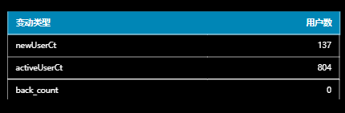

### 3.3.3 用户行为漏斗分析

**1）需求介绍**

漏斗分析是一个数据分析模型，它能够科学反映一个业务过程从起点到终点各阶段用户转化情况。由于其能将各阶段环节都展示出来，故哪个阶段存在问题，就能一目了然。

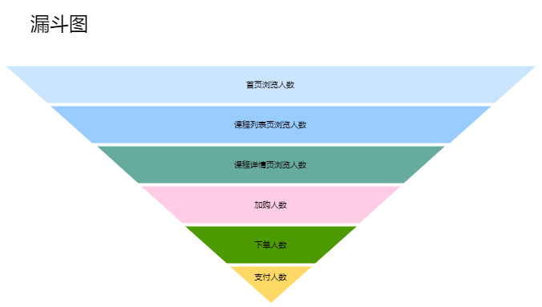

该需求要求统计一个完整的购物流程各个阶段的人数，具体说明如下：

|  |  |  |
| --- | --- | --- |
| 统计周期 | 指标 | 说明 |
| 当日 | 首页浏览人数 | 略 |
| 当日 | 课程列表页浏览人数 | 略 |
| 当日 | 课程详情页浏览人数 | 略 |
| 当日 | 加购人数 | 略 |
| 当日 | 下单人数 | 略 |
| 当日 | 支付人数 | 支付成功人数 |

**2）需求分析**

本节指标展示使用表格实现。

**3）数据结构**

{

"status": 0,

"msg": "",

"data": {

"columns": [

{

"name": "页面",

"id": "page_id"

},

{

"name": "独立访客数",

"id": "uv_ct"

}

],

"rows": [

{

"page_id": "home",

"uv_ct": "2820"

},

{

"page_id": "good_detail",

"uv_ct": "2638"

},

{

"page_id": "payment",

"uv_ct": "242"

},

{

"page_id": "cart",

"uv_ct": "1178"

},

{

"page_id": "trade",

"uv_ct": "1681"

}

]

}

}

**4）Mapper 层**

（1）实体类

package com.atguigu.edu.publisher.bean;

import lombok.AllArgsConstructor;

import lombok.Data;

@Data

@AllArgsConstructor

public class UserPageCt {

// 页面 id

String pageId;

//独立访客数

Integer uvCt;

}

（2）Mapper 接口

在 UserStatsMapper 接口中补充查询方法。

@Select("select page_id,\n" +

" uvCt\n" +

"from\n" +

"(select 'home' page_id,\n" +

" sum(home_uv_count) uvCt\n" +

" from dws_traffic_page_view_window\n" +

" where toYYYYMMDD(stt) = #{date}\n" +

" union all\n" +

"select 'list_uv' page_id,\n" +

" sum(list_uv_count) uvCt\n" +

" from dws_traffic_page_view_window\n" +

" where toYYYYMMDD(stt) = #{date}\n" +

" union all\n" +

"select 'detail_uv' page_id,\n" +

" sum(detail_uv_count) uvCt\n" +

" from dws_traffic_page_view_window\n" +

" where toYYYYMMDD(stt) = #{date}\n" +

" union all\n" +

"select 'cart' page_id,\n" +

" sum(cart_add_uv_count) uvCt\n" +

" from dws_trade_cart_add_window\n" +

" where toYYYYMMDD(stt) = #{date}\n" +

" union all\n" +

"select 'trade' page_id,\n" +

" sum(order_uv_count) uvCt\n" +

" from dws_trade_order_window\n" +

" where toYYYYMMDD(stt) = #{date}\n" +

" union all\n" +

"select 'payment' page_id,\n" +

" sum(pay_suc_uv_count) uvCt\n" +

" from dws_trade_pay_suc_window\n" +

" where toYYYYMMDD(stt) = #{date}\n" +

") all_data order by uvCt desc;")

List<UserPageCt> selectUvByPage(@Param("date") Integer date);

**5）Service 层**

（1）Service 接口

在 UserStatsService 接口中补充方法。

List<UserPageCt> getUvByPage(Integer date);

（2）Service 实现类

在实现类 UserStatsServiceImpl 中补充方法

@Override

public List<UserPageCt> getUvByPage(Integer date) {

return userStatsMapper.selectUvByPage(date);

}

**6）Controller 层**

在 UserStatsController 控制类中补充方法

@RequestMapping("/uvPerPage")

public String getUvPerPage(

@RequestParam(value = "date", defaultValue = "1") Integer date) {

if (date == 1) {

date = DateUtil.now();

}

List<UserPageCt> uvByPageList = userStatsService.getUvByPage(date);

if (uvByPageList == null) {

return "";

}

StringBuilder rows = new StringBuilder("[");

for (int i = 0; i < uvByPageList.size(); i++) {

UserPageCt userPageCt = uvByPageList.get(i);

String pageId = userPageCt.getPageId();

Integer uvCt = userPageCt.getUvCt();

rows.append("{\n" +

" \"page_id\": \"" + pageId + "\",\n" +

" \"uv_ct\": \"" + uvCt + "\"\n" +

" }");

if (i < uvByPageList.size() - 1) {

rows.append(",");

} else {

rows.append("]");

}

}

return "{\n" +

" \"status\": 0,\n" +

" \"msg\": \"\",\n" +

" \"data\": {\n" +

" \"columns\": [\n" +

" {\n" +

" \"name\": \"页面\",\n" +

" \"id\": \"page_id\"\n" +

" },\n" +

" {\n" +

" \"name\": \"独立访客数\",\n" +

" \"id\": \"uv_ct\"\n" +

" }\n" +

" ],\n" +

" \"rows\": " + rows + "\n" +

" }\n" +

"}";

}

**7）Sugar 配置**

① 选择轮播表格

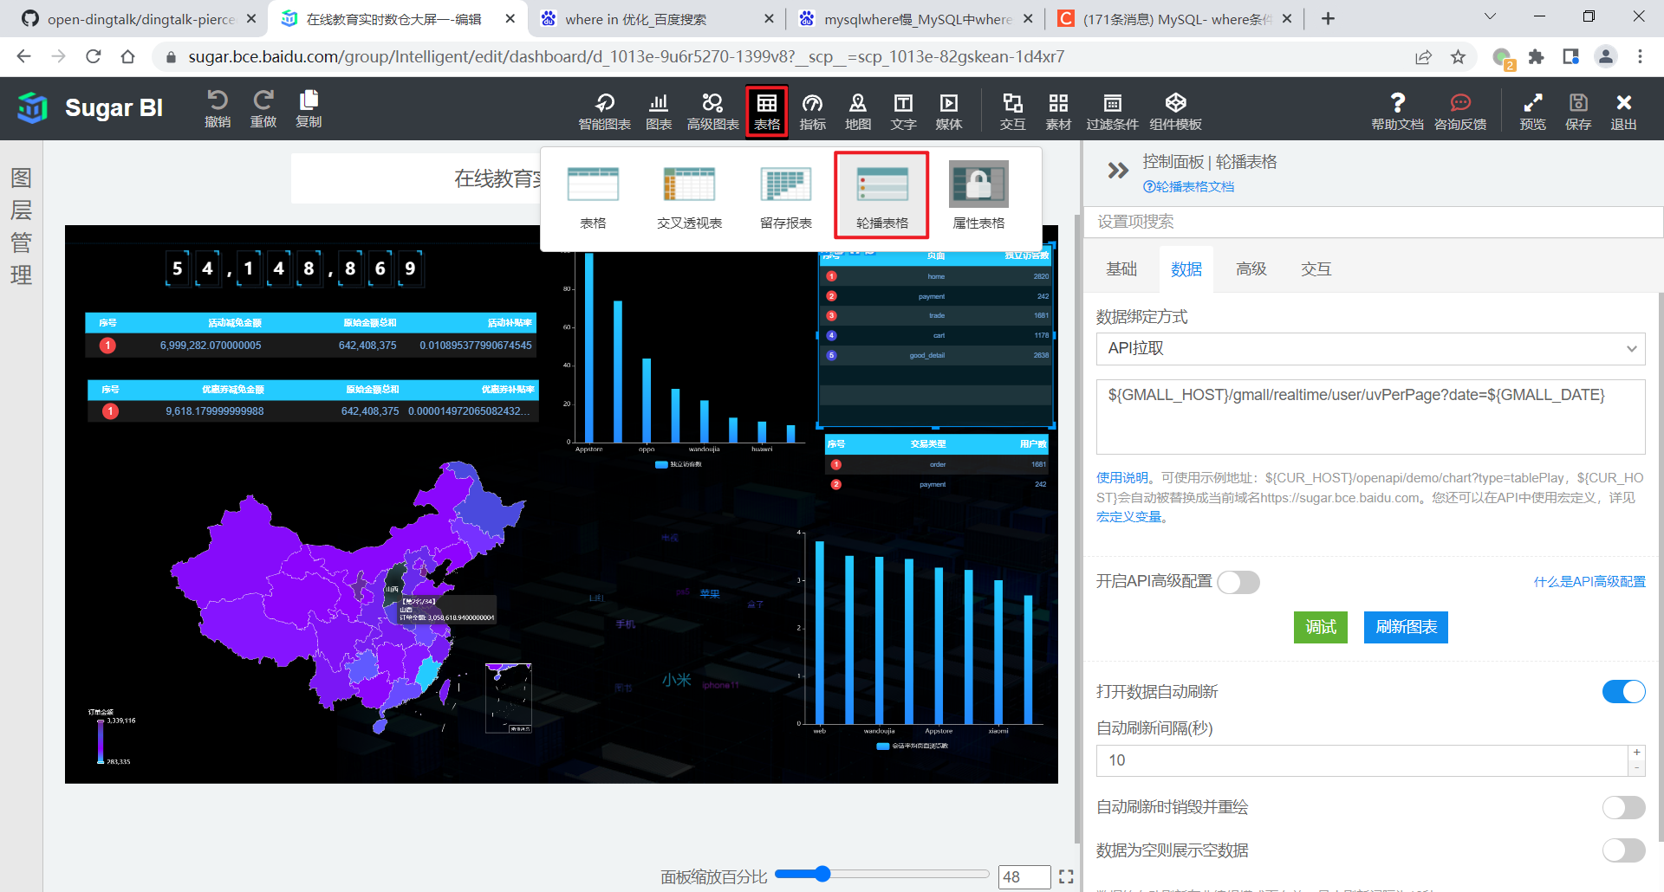

② 数据绑定方式为 “API 拉取”，输入数据接口的 URL，如下。

${EDU_HOST}/edu/realtime/user/uvPerPage?date=${EDU_DATE}

③ 效果如下

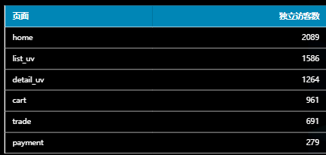

### 3.3.4 新增交易用户统计

**1）需求说明**

|  |  |  |
| --- | --- | --- |
| 统计周期 | 指标 | 说明 |
| 当日 | 新增下单人数 | 略 |
| 当日 | 新增支付成功人数 | 略 |

**2）需求分析**

本节指标展示使用表格实现。

**3）数据结构**

{

"status": 0,

"msg": "",

"data": {

"columns": [

{

"name": "交易类型",

"id": "type"

},

{

"name": "新增用户数",

"id": "user_ct"

}

],

"rows": [

{

"type": "order",

"user_ct": "1681"

},

{

"type": "payment",

"user_ct": "242"

}

]

}

}

**4）Mapper 层**

（1）实体类

package com.atguigu.edu.publisher.bean;

import lombok.AllArgsConstructor;

import lombok.Data;

@Data

@AllArgsConstructor

public class UserTradeCt {

// 交易类型

String type;

// 用户数

Integer userCt;

}

（2）Mapper 接口

在 UserStatsMapper 类中补充方法。

@Select("select 'order' trade_type,\n" +

" sum(new_order_user_count) new_order_user_count\n" +

" from dws_trade_order_window\n" +

" where toYYYYMMDD(stt) = #{date}\n" +

" union all\n" +

"select 'payment' trade_type,\n" +

" sum(pay_suc_new_user_count) pay_suc_new_user_count\n" +

" from dws_trade_pay_suc_window\n" +

" where toYYYYMMDD(stt) = #{date};")

List<UserTradeCt> selectTradeUserCt(@Param("date")Integer date);

**5）Service 层**

（1）Service 接口

在 UserStatsService 接口中补充方法。

List<UserTradeCt> getTradeUserCt(Integer date);

（2）Service 实现类

在 UserStatsServiceImpl 实现类中补充方法。

@Override

public List<UserTradeCt> getTradeUserCt(Integer date) {

return userStatsMapper.selectTradeUserCt(date);

}

**6）Controller 层**

在 UserStatsController 控制类中补充方法。

@RequestMapping("/userTradeCt")

public String getUserTradeCt(

@RequestParam(value = "date", defaultValue = "1") Integer date) {

if (date == 1) {

date = DateUtil.now();

}

List<UserTradeCt> tradeUserCtList = userStatsService.getTradeUserCt(date);

if (tradeUserCtList == null) {

return "";

}

StringBuilder rows = new StringBuilder("[");

for (int i = 0; i < tradeUserCtList.size(); i++) {

UserTradeCt userTradeCt = tradeUserCtList.get(i);

String type = userTradeCt.getType();

Integer userCt = userTradeCt.getUserCt();

rows.append("{\n" +

"\t\"type\": \"" + type + "\",\n" +

"\t\"user_ct\": \"" + userCt + "\"\n" +

"}");

if (i < tradeUserCtList.size() - 1) {

rows.append(",");

} else {

rows.append("]");

}

}

return "{\n" +

" \"status\": 0,\n" +

" \"msg\": \"\",\n" +

" \"data\": {\n" +

" \"columns\": [\n" +

" {\n" +

" \"name\": \"交易类型\",\n" +

" \"id\": \"type\"\n" +

" },\n" +

" {\n" +

" \"name\": \"新增用户数\",\n" +

" \"id\": \"user_ct\"\n" +

" }\n" +

" ],\n" +

" \"rows\": " + rows + "\n" +

" }\n" +

"}";

}

**7）Sugar 配置**

① 选择轮播表格，数据绑定方式为 “API 拉取”，输入数据接口的 URL，如下。

${EDU_HOST}/edu/realtime/user/userTradeCt?date=${EDU_DATE}

② 效果如下

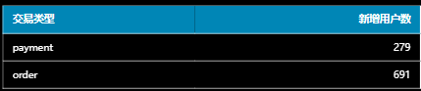

## 3.4 交易主题

### 3.4.1 各来源交易统计

**1）需求说明**

|  |  |  |  |
| --- | --- | --- | --- |
| 统计周期 | 统计粒度 | 指标 | 说明 |
| 当日 | 来源 | 订单总额 | 略 |
| 当日 | 来源 | 下单人数 | 略 |
| 当日 | 来源 | 订单数 | 略 |

**2）需求分析**

本节数据将通过轮播表格展示。

**3）数据结构**

略。

**4）Mapper 层**

（1）实体类

package com.atguigu.edu.publisher.bean;

import lombok.AllArgsConstructor;

import lombok.Data;

import java.math.BigDecimal;

@Data

@AllArgsConstructor

public class TradeSourceStats {

// 来源名称

String SourceName;

// 订单总额

BigDecimal orderTotalAmount;

// 下单独立用户数

Long orderUuCt;

// 订单数

Long orderCt;

}

（2）Mapper 接口

package com.atguigu.edu.publisher.mapper;

import com.atguigu.edu.publisher.bean.*;

import org.apache.ibatis.annotations.Param;

import org.apache.ibatis.annotations.Select;

import java.math.BigDecimal;

import java.util.List;

public interface TradeStatsMapper {

// 各来源交易统计

@Select("select source_name,\n" +

" sum(order_total_amount) order_total_amount,\n" +

" sum(order_uu_count) order_uu_ct,\n" +

" sum(order_count) order_ct\n" +

"from dws_trade_source_order_window\n" +

"where toYYYYMMDD(stt) = #{date}\n" +

"group by toYYYYMMDD(stt), source_id, source_name\n" +

"order by order_total_amount desc\n" +

"limit 10;")

List<TradeSourceStats> selectTradeSourceStats(@Param("date") Integer date);

}

**5）Service 层**

（1）Service 接口

package com.atguigu.edu.publisher.service;

import com.atguigu.edu.publisher.bean.*;

import java.math.BigDecimal;

import java.util.List;

public interface TradeStatsService {

List<TradeSourceStats> getTradeSourceStats(Integer date);

}

（2）Service 实现类

package com.atguigu.edu.publisher.service.impl;

import com.atguigu.edu.publisher.bean.*;

import com.atguigu.edu.publisher.mapper.TradeStatsMapper;

import com.atguigu.edu.publisher.service.TradeStatsService;

import org.springframework.beans.factory.annotation.Autowired;

import org.springframework.stereotype.Service;

import java.math.BigDecimal;

import java.util.List;

@Service

public class TradeStatsServiceImpl implements TradeStatsService {

@Autowired

private TradeStatsMapper tradeStatsMapper;

@Override

public List<TradeSourceStats> getTradeSourceStats(Integer date) {

return tradeStatsMapper.selectTradeSourceStats(date);

}

}

**6）Controller 层**

package com.atguigu.edu.publisher.controller;

import com.atguigu.edu.publisher.bean.*;

import com.atguigu.edu.publisher.service.TradeStatsService;

import com.atguigu.edu.publisher.util.DateUtil;

import org.springframework.beans.factory.annotation.Autowired;

import org.springframework.web.bind.annotation.RequestMapping;

import org.springframework.web.bind.annotation.RequestParam;

import org.springframework.web.bind.annotation.RestController;

import java.math.BigDecimal;

import java.util.List;

@RestController

@RequestMapping("/edu/realtime/trade")

public class TradeController {

@Autowired

private TradeStatsService tradeStatsService;

@RequestMapping("/sourceStats")

public String getStats(

@RequestParam(value = "date", defaultValue = "1") Integer date) {

if (date == 1) {

date = DateUtil.now();

}

List<TradeSourceStats> tradeSourceStatsList = tradeStatsService.getTradeSourceStats(date);

if (tradeSourceStatsList == null || tradeSourceStatsList.size() == 0) {

return "";

}

StringBuilder rows = new StringBuilder("[");

for (int i = 0; i < tradeSourceStatsList.size(); i++) {

TradeSourceStats tradeSourceStats = tradeSourceStatsList.get(i);

String sourceName = tradeSourceStats.getSourceName();

BigDecimal orderTotalAmount = tradeSourceStats.getOrderTotalAmount();

Long orderUuCt = tradeSourceStats.getOrderUuCt();

Long orderCt = tradeSourceStats.getOrderCt();

rows.append("{\n" +

" \"source_name\": \"" + sourceName + "\",\n" +

" \"order_total_amount\": \"" + orderTotalAmount + "\",\n" +

" \"order_uu_count\": \"" + orderUuCt + "\",\n" +

" \"order_count\": \"" + orderCt + "\"\n" +

" }");

if (i < tradeSourceStatsList.size() - 1) {

rows.append(",");

} else {

rows.append("]");

}

}

return "{\n" +

" \"status\": 0,\n" +

" \"msg\": \"\",\n" +

" \"data\": {\n" +

" \"columns\": [\n" +

" {\n" +

" \"name\": \"来源名称\",\n" +

" \"id\": \"source_name\"\n" +

" },\n" +

" {\n" +

" \"name\": \"订单总额\",\n" +

" \"id\": \"order_total_amount\"\n" +

" },\n" +

" {\n" +

" \"name\": \"下单用户总数\",\n" +

" \"id\": \"order_uu_count\"\n" +

" },\n" +

" {\n" +

" \"name\": \"订单总数\",\n" +

" \"id\": \"order_count\"\n" +

" }\n" +

" ],\n" +

" \"rows\": \n" + rows +

" \n" +

" }\n" +

"}";

}

}

**7）Sugar 配置**

① 选择轮播表格

略。

② 数据绑定方式为 “API 拉取”，输入数据接口的 URL，如下。

${EDU_HOST}/edu/realtime/trade/sourceStats?date=${EDU_DATE}

③ 效果如下

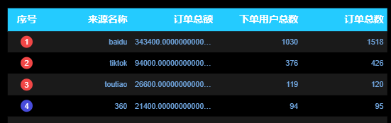

### 3.4.2 各省份交易统计

**1）需求说明**

|  |  |  |  |
| --- | --- | --- | --- |
| 统计周期 | 统计粒度 | 指标 | 说明 |
| 当日 | 省份 | 订单总额 | 略 |
| 当日 | 省份 | 下单人数 | 略 |
| 当日 | 省份 | 订单数 |  |

**2）需求分析**

本节将为三个指标各生成一张中国省份色彩地图。

**3）数据结构**

{

"status": 0,

"msg": "",

"data": {

"mapData": [

{

"name": "内蒙古",

"value": 12

},

{

"name": "上海",

"value": 10

},

...

],

"valueName": "订单数"

}

}

**4）Mapper 层**

（1）实体类

① 订单金额实体类

package com.atguigu.edu.publisher.bean;

import lombok.AllArgsConstructor;

import lombok.Data;

import java.math.BigDecimal;

@Data

@AllArgsConstructor

public class TradeProvinceOrderAmount {

// 省份名称

String provinceName;

// 订单总额

BigDecimal orderTotalAmount;

}

② 下单人数实体类

package com.atguigu.edu.publisher.bean;

import lombok.AllArgsConstructor;

import lombok.Data;

import java.math.BigDecimal;

@Data

@AllArgsConstructor

public class TradeProvinceOrderUuCount {

// 省份名称

String provinceName;

// 下单独立用户数

Long orderUuCt;

}

③ 订单数实体类

package com.atguigu.edu.publisher.bean;

import lombok.AllArgsConstructor;

import lombok.Data;

@Data

@AllArgsConstructor

public class TradeProvinceOrderCount {

// 省份名称

String provinceName;

// 订单数

Long orderCt;

}

（2）Mapper 接口

在 TradeStatsMapper 接口中补充方法。

**// 各省份订单总额**

@Select("select province_name,\n" +

" sum(order_total_amount) order_total_amount\n" +

"from dws_trade_province_order_window\n" +

"where toYYYYMMDD(stt) = #{date}\n" +

"group by toYYYYMMDD(stt), province_id, province_name;")

List<TradeProvinceOrderAmount> selectTradeProvinceOrderAmount(@Param("date") Integer date);

**// 各省份下单总人数**

@Select("select province_name,\n" +

" sum(order_uu_count) order_uu_ct\n" +

"from dws_trade_province_order_window\n" +

"where toYYYYMMDD(stt) = #{date}\n" +

"group by toYYYYMMDD(stt), province_id, province_name;")

List<TradeProvinceOrderUuCount> selectTradeProvinceOrderUuCount(@Param("date") Integer date);

**// 各省份订单总数**

@Select("select province_name,\n" +

" sum(order_count) order_ct\n" +

"from dws_trade_province_order_window\n" +

"where toYYYYMMDD(stt) = #{date}\n" +

"group by toYYYYMMDD(stt), province_id, province_name;")

List<TradeProvinceOrderCount> selectTradeProvinceOrderCount(@Param("date") Integer date);

**5）Service 层**

（1）Service 接口

在 TradeStatsService 接口中补充方法。

List<TradeProvinceOrderAmount> getTradeProvinceOrderAmount(Integer date);

List<TradeProvinceOrderUuCount> getTradeProvinceOrderUuCount(Integer date);

List<TradeProvinceOrderCount> getTradeProvinceOrderCount(Integer date);

（2）Service 实现类

在 TradeStatsServiceImpl 实现类中补充方法。

@Override

public List<TradeProvinceOrderAmount> getTradeProvinceOrderAmount(Integer date) {

return tradeStatsMapper.selectTradeProvinceOrderAmount(date);

}

@Override

public List<TradeProvinceOrderUuCount> getTradeProvinceOrderUuCount(Integer date) {

return tradeStatsMapper.selectTradeProvinceOrderUuCount(date);

}

@Override

public List<TradeProvinceOrderCount> getTradeProvinceOrderCount(Integer date) {

return tradeStatsMapper.selectTradeProvinceOrderCount(date);

}

**6）Controller 层**

在 TradeController 控制类中补充方法。

@RequestMapping("/provinceOrderAmount")

public String getProvinceOrderAmount(

@RequestParam(value = "date", defaultValue = "1") Integer date) {

if (date == 1) {

date = DateUtil.now();

}

List<TradeProvinceOrderAmount> tradeProvinceOrderAmountList = tradeStatsService.getTradeProvinceOrderAmount(date);

if (tradeProvinceOrderAmountList == null || tradeProvinceOrderAmountList.size() == 0) {

return "";

}

StringBuilder mapData = new StringBuilder("[");

for (int i = 0; i < tradeProvinceOrderAmountList.size(); i++) {

TradeProvinceOrderAmount tradeProvinceOrderAmount = tradeProvinceOrderAmountList.get(i);

String provinceName = tradeProvinceOrderAmount.getProvinceName();

BigDecimal orderAmount = tradeProvinceOrderAmount.getOrderTotalAmount();

mapData.append("{\n" +

" \"name\": \"" + provinceName + "\",\n" +

" \"value\": " + orderAmount + "\n" +

" }");

if (i < tradeProvinceOrderAmountList.size() - 1) {

mapData.append(",");

} else {

mapData.append("]");

}

}

return "{\n" +

" \"status\": 0,\n" +

" \"msg\": \"\",\n" +

" \"data\": {\n" +

" \"mapData\": " + mapData + ",\n" +

" \"valueName\": \"订单金额\"\n" +

" }\n" +

"}";

}

@RequestMapping("/provinceOrderUuCt")

public String getProvinceOrderUuCt(

@RequestParam(value = "date", defaultValue = "1") Integer date) {

if (date == 1) {

date = DateUtil.now();

}

List<TradeProvinceOrderUuCount> tradeProvinceOrderUuCountList = tradeStatsService.getTradeProvinceOrderUuCount(date);

if (tradeProvinceOrderUuCountList == null || tradeProvinceOrderUuCountList.size() == 0) {

return "";

}

StringBuilder mapData = new StringBuilder("[");

for (int i = 0; i < tradeProvinceOrderUuCountList.size(); i++) {

TradeProvinceOrderUuCount tradeProvinceOrderUuCount = tradeProvinceOrderUuCountList.get(i);

String provinceName = tradeProvinceOrderUuCount.getProvinceName();

Long orderUuCt = tradeProvinceOrderUuCount.getOrderUuCt();

mapData.append("{\n" +

" \"name\": \"" + provinceName + "\",\n" +

" \"value\": " + orderUuCt + "\n" +

" }");

if (i < tradeProvinceOrderUuCountList.size() - 1) {

mapData.append(",");

} else {

mapData.append("]");

}

}

return "{\n" +

" \"status\": 0,\n" +

" \"msg\": \"\",\n" +

" \"data\": {\n" +

" \"mapData\": " + mapData + ",\n" +

" \"valueName\": \"下单独立用户数\"\n" +

" }\n" +

"}";

}

@RequestMapping("/provinceOrderCt")

public String getProvinceOrderCt(

@RequestParam(value = "date", defaultValue = "1") Integer date) {

if (date == 1) {

date = DateUtil.now();

}

List<TradeProvinceOrderCount> tradeProvinceOrderCountList = tradeStatsService.getTradeProvinceOrderCount(date);

if (tradeProvinceOrderCountList == null || tradeProvinceOrderCountList.size() == 0) {

return "";

}

StringBuilder mapData = new StringBuilder("[");

for (int i = 0; i < tradeProvinceOrderCountList.size(); i++) {

TradeProvinceOrderCount tradeProvinceOrderCount = tradeProvinceOrderCountList.get(i);

String provinceName = tradeProvinceOrderCount.getProvinceName();

Long orderCt = tradeProvinceOrderCount.getOrderCt();

mapData.append("{\n" +

" \"name\": \"" + provinceName + "\",\n" +

" \"value\": " + orderCt + "\n" +

" }");

if (i < tradeProvinceOrderCountList.size() - 1) {

mapData.append(",");

} else {

mapData.append("]");

}

}

return "{\n" +

" \"status\": 0,\n" +

" \"msg\": \"\",\n" +

" \"data\": {\n" +

" \"mapData\": " + mapData + ",\n" +

" \"valueName\": \"订单数\"\n" +

" }\n" +

"}";

}

**7）Sugar 配置**

① 选择中国省份色彩地图

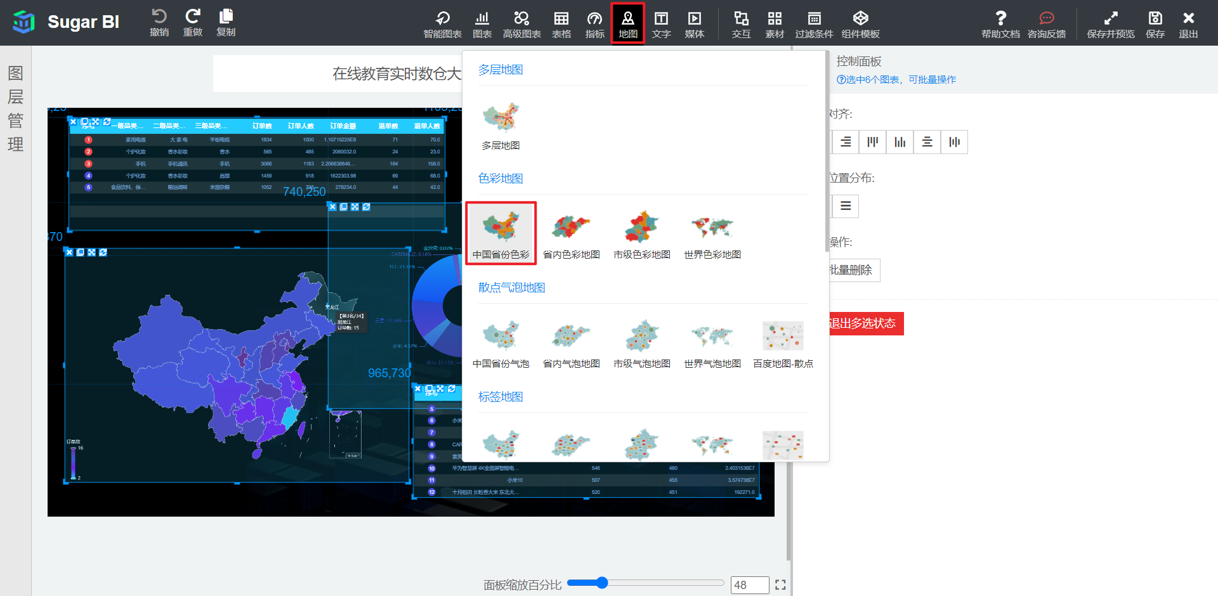

② 数据绑定方式为 “API 拉取”，输入数据接口的 URL，如下。

**# 订单金额 URL**

${EDU_HOST}/edu/realtime/trade/provinceOrderAmount?date=${EDU_DATE}

**# 订单人数 URL**

${EDU_HOST}/edu/realtime/trade/provinceOrderUuCt?date=${EDU_DATE}

**# 订单数 URL**

${EDU_HOST}/edu/realtime/trade/provinceOrderCt?date=${EDU_DATE}

③ 效果如下

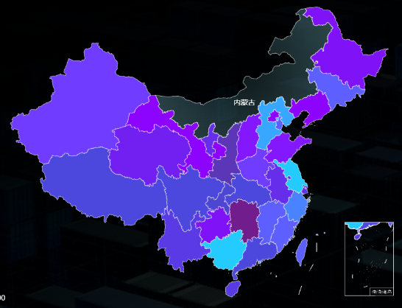

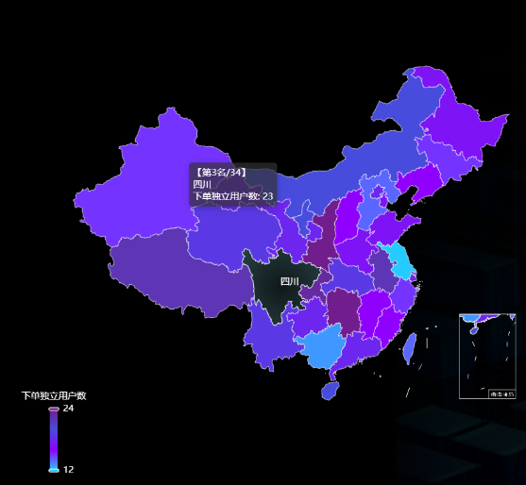

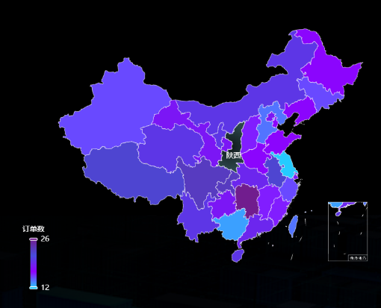

### 3.4.3 交易综合统计

**1）需求说明**

|  |  |  |
| --- | --- | --- |
| 统计周期 | 指标 | 说明 |
| 当日 | 订单总额 | 订单最终金额 |
| 当日 | 订单数 | 略 |

**2）需求分析**

本节指标将通过数字翻牌器展示。

**3）数据结构**

（1）数字翻牌器

{

"status": 0,

"msg": "",

"data": 54148869.14

}

**4）Mapper 层**

（1）实体类

数字翻牌器无须实体类。

（2）Mapper 接口

在 TradeStatsMapper 中补充方法

// 交易总金额

@Select("select sum(order_total_amount) order_total_amount\n" +

"from dws_trade_source_order_window\n" +

"where toYYYYMMDD(stt) = #{date};")

BigDecimal selectOrderTotalAmount(@Param("date") Integer date);

// 订单总数

@Select("select sum(order_count) order_total_count\n" +

"from dws_trade_source_order_window\n" +

"where toYYYYMMDD(stt) = #{date};")

Long selectOrderTotalCt(@Param("date") Integer date);

**5）Service 层**

（1）Service 接口

在 TradeStatsService 接口中补充方法。

BigDecimal getOrderTotalAmount(Integer date);

Long getOrderTotalCount(Integer date);

（2）Service 实现类

在 TradeStatsServiceImpl 实现类中补充方法。

public BigDecimal getOrderTotalAmount(Integer date) {

return tradeStatsMapper.selectOrderTotalAmount(date);

}

@Override

public Long getOrderTotalCount(Integer date) {

return tradeStatsMapper.selectOrderTotalCt(date);

}

**6）Controller 层**

在控制层 TradeController 中补充方法。

**// 订单总额**

@RequestMapping("/gmv")

public String getTotalAmount(

@RequestParam(value = "date", defaultValue = "1") Integer date) {

if (date == 1) {

date = DateUtil.now();

}

BigDecimal totalAmount = tradeStatsService.getOrderTotalAmount(date);

if (totalAmount == null) {

return "";

}

return "{\n" +

" \"status\": 0,\n" +

" \"msg\": \"\",\n" +

" \"data\": " + totalAmount + "\n" +

"}";

}

**// 订单总数**

@RequestMapping("/orderTotalCount")

public String getOrderTotalCount(

@RequestParam(value = "date", defaultValue = "1") Integer date) {

if (date == 1) {

date = DateUtil.now();

}

Long orderTotalCount = tradeStatsService.getOrderTotalCount(date);

if (orderTotalCount == null) {

return "";

}

return "{\n" +

" \"status\": 0,\n" +

" \"msg\": \"\",\n" +

" \"data\": " + orderTotalCount + "\n" +

"}";

}

**7）Sugar 配置**

① 选择数字翻牌器

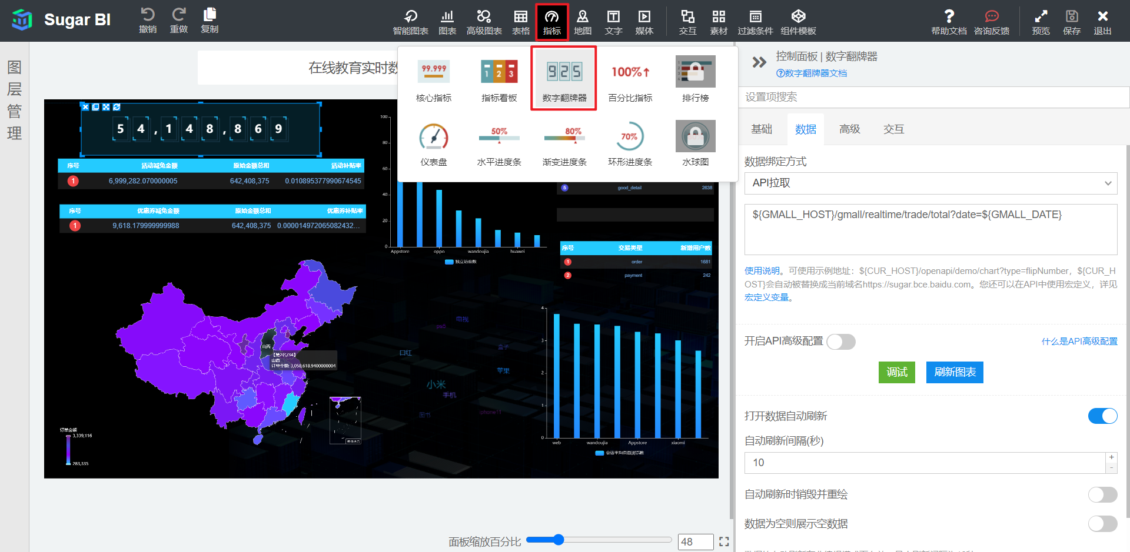

② 数据绑定方式为 “API 拉取”，输入数据接口的 URL，如下。

**# 订单总额**

${EDU_HOST}/edu/realtime/trade/gmv?date=${EDU_DATE}

**# 订单总数**

${EDU_HOST}/edu/realtime/trade/orderTotalCount?date=${EDU_DATE}

③ 效果如下

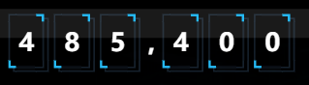



## 3.5 课程主题

### 3.5.1 下单情况统计

**1）需求说明**

|  |  |  |  |
| --- | --- | --- | --- |
| 统计周期 | 统计粒度 | 指标 | 说明 |
| 当日 | 学科 | 下单金额 | 略 |
| 当日 | 类别 | 下单金额 | 略 |
| 当日 | 课程 | 下单金额 | 略 |

**2）需求分析**

本节指标的展示使用轮播表格实现。

**3）数据结构**

略。

**4）Mapper 层**

（1）实体类

① 各课程订单总额实体类

package com.atguigu.edu.publisher.bean;

import lombok.AllArgsConstructor;

import lombok.Data;

import java.math.BigDecimal;

@Data

@AllArgsConstructor

public class CourseOrderStats {

// 课程名称

String courseName;

// 订单总额

BigDecimal orderTotalAmount;

}

② 各科目订单总额实体类

package com.atguigu.edu.publisher.bean;

import lombok.AllArgsConstructor;

import lombok.Data;

import java.math.BigDecimal;

@Data

@AllArgsConstructor

public class SubjectOrderStats {

// 科目名称

private String subjectName;

// 订单总额

private BigDecimal orderTotalAmount;

}

③ 各类别订单总额实体类

package com.atguigu.edu.publisher.bean;

import lombok.AllArgsConstructor;

import lombok.Data;

import lombok.NoArgsConstructor;

import java.math.BigDecimal;

@Data

@AllArgsConstructor

public class Category0rderStats {

// 类别名称

String categoryName;

// 订单总额

BigDecimal orderTotalAmount;

}

（2）Mapper 接口

package com.atguigu.edu.publisher.mapper;

import com.atguigu.edu.publisher.bean.*;

import org.apache.ibatis.annotations.Param;

import org.apache.ibatis.annotations.Select;

import java.util.List;

public interface CourseStatsMapper {

@Select("select course_name,\n" +

" sum(order_total_amount) order_total_amount\n" +

"from dws_trade_course_order_window\n" +

"where toYYYYMMDD(stt) = #{date}\n" +

"group by course_id, course_name\n" +

"order by order_total_amount desc\n" +

"limit 10;")

List<CourseOrderStats> selectCourseOrderStats(@Param("date") Integer date);

@Select("select subject_name,\n" +

" sum(order_total_amount) order_total_amount\n" +

"from dws_trade_course_order_window\n" +

"where toYYYYMMDD(stt) = #{date}\n" +

"group by subject_id, subject_name\n" +

"order by order_total_amount desc;")

List<SubjectOrderStats> selectSubjectOrderStats(@Param("date")Integer date);

@Select("select category_name,\n" +

" sum(order_total_amount) order_total_amount\n" +

"from dws_trade_course_order_window\n" +

"where toYYYYMMDD(stt) = #{date}\n" +

"group by category_id, category_name\n" +

"order by order_total_amount desc")

List<Category0rderStats> selectCategoryOrderStats(@Param("date") Integer date);

}

**5）Service 层**

（1）Service 接口

package com.atguigu.edu.publisher.service;

import com.atguigu.edu.publisher.bean.*;

import java.util.List;

public interface CourseStatsService {

List<CourseOrderStats> getCourseOrderStats(Integer date);

List<SubjectOrderStats> getSubjectOrderStats(Integer date);

List<Category0rderStats> getCategoryOrderStats(Integer date);

}

（2）Service 实现类

package com.atguigu.edu.publisher.service.impl;

import com.atguigu.edu.publisher.bean.*;

import com.atguigu.edu.publisher.mapper.CourseStatsMapper;

import com.atguigu.edu.publisher.service.CourseStatsService;

import org.springframework.beans.factory.annotation.Autowired;

import org.springframework.stereotype.Service;

import java.util.List;

@Service

public class CourseStatsServiceImpl implements CourseStatsService {

@Autowired

private CourseStatsMapper courseStatsMapper;

@Override

public List<CourseOrderStats> getCourseOrderStats(Integer date) {

return courseStatsMapper.selectCourseOrderStats(date);

}

@Override

public List<SubjectOrderStats> getSubjectOrderStats(Integer date) {

return courseStatsMapper.selectSubjectOrderStats(date);

}

@Override

public List<Category0rderStats> getCategoryOrderStats(Integer date) {

return courseStatsMapper.selectCategoryOrderStats(date);

}

}

**6）Controller 层**

package com.atguigu.edu.publisher.controller;

import com.atguigu.edu.publisher.bean.*;

import com.atguigu.edu.publisher.service.CourseStatsService;

import com.atguigu.edu.publisher.util.DateUtil;

import org.springframework.beans.factory.annotation.Autowired;

import org.springframework.web.bind.annotation.RequestMapping;

import org.springframework.web.bind.annotation.RequestParam;

import org.springframework.web.bind.annotation.RestController;

import java.math.BigDecimal;

import java.util.List;

@RestController

@RequestMapping("/edu/realtime/course")

public class CourseStatsController {

@Autowired

private CourseStatsService courseStatsService;

@RequestMapping("/courseOrderStats")

public String getCourseOrderStats(

@RequestParam(value = "date", defaultValue = "1") Integer date) {

if (date == 1) {

date = DateUtil.now();

}

List<CourseOrderStats> courseOrderStats = courseStatsService.getCourseOrderStats(date);

if (courseOrderStats == null || courseOrderStats.size() == 0) {

return "";

}

StringBuilder rows = new StringBuilder("[");

for (int i = 0; i < courseOrderStats.size(); i++) {

CourseOrderStats courseOrderStat = courseOrderStats.get(i);

String courseName = courseOrderStat.getCourseName();

BigDecimal orderTotalAmount = courseOrderStat.getOrderTotalAmount();

rows.append("{\n" +

"\t\"course_name\": \"" + courseName + "\",\n" +

"\t\"order_total_amount\": \"" + orderTotalAmount + "\"\n" +

"}");

if (i < courseOrderStats.size() - 1) {

rows.append(",");

} else {

rows.append("]");

}

}

String str = "{\n" +

" \"status\": 0,\n" +

" \"msg\": \"\",\n" +

" \"data\": {\n" +

" \"columns\": [\n" +

" {\n" +

" \"name\": \"课程名称\",\n" +

" \"id\": \"course_name\"\n" +

" },\n" +

" {\n" +

" \"name\": \"订单金额\",\n" +

" \"id\": \"order_total_amount\"\n" +

" }\n" +

" ],\n" +

" \"rows\": " + rows + "\n" +

" }\n" +

"}";

String finalStr = str.replaceAll("\\\\", ",");

return finalStr;

}

@RequestMapping("/subjectOrderStats")

public String getSubjectOrderStats(

@RequestParam(value = "date", defaultValue = "1") Integer date) {

if (date == 1) {

date = DateUtil.now();

}

List<SubjectOrderStats> subjectOrderStats = courseStatsService.getSubjectOrderStats(date);

if (subjectOrderStats == null || subjectOrderStats.size() == 0) {

return "";

}

StringBuilder rows = new StringBuilder("[");

for (int i = 0; i < subjectOrderStats.size(); i++) {

SubjectOrderStats subjectOrderStat = subjectOrderStats.get(i);

String subjectName = subjectOrderStat.getSubjectName();

BigDecimal orderTotalAmount = subjectOrderStat.getOrderTotalAmount();

rows.append("{\n" +

" \"subject_name\": \"" + subjectName + "\",\n" +

" \"order_total_amount\": " + orderTotalAmount + "\n" +

" }");

if (i < subjectOrderStats.size() - 1) {

rows.append(",");

} else {

rows.append("]");

}

}

return "{\n" +

" \"status\": 0,\n" +

" \"msg\": \"\",\n" +

" \"data\": {\n" +

" \"columns\": [\n" +

" {\n" +

" \"name\": \"科目名称\",\n" +

" \"id\": \"subject_name\"\n" +

" },\n" +

" {\n" +

" \"name\": \"订单金额\",\n" +

" \"id\": \"order_total_amount\"\n" +

" }\n" +

" ],\n" +

" \"rows\": " + rows + "\n" +

" }\n" +

"}";

}

@RequestMapping("/categoryOrderStats")

public String getCategoryOrderStats(

@RequestParam(value = "date", defaultValue = "1") Integer date) {

if (date == 1) {

date = DateUtil.now();

}

List<Category0rderStats> categoryOrderStats = courseStatsService.getCategoryOrderStats(date);

if (categoryOrderStats == null || categoryOrderStats.size() == 0) {

return "";

}

StringBuilder rows = new StringBuilder("[");

for (int i = 0; i < categoryOrderStats.size(); i++) {

Category0rderStats category0rderStat = categoryOrderStats.get(i);

String categoryName = category0rderStat.getCategoryName();

BigDecimal orderTotalAmount = category0rderStat.getOrderTotalAmount();

rows.append("{\n" +

" \"category_name\": \"" + categoryName + "\",\n" +

" \"order_total_amount\": " + orderTotalAmount + "\n" +

" }");

if (i < categoryOrderStats.size() - 1) {

rows.append(",");

} else {

rows.append("]");

}

}

return "{\n" +

" \"status\": 0,\n" +

" \"msg\": \"\",\n" +

" \"data\": {\n" +

" \"columns\": [\n" +

" {\n" +

" \"name\": \"类别名称\",\n" +

" \"id\": \"category_name\"\n" +

" },\n" +

" {\n" +

" \"name\": \"订单金额\",\n" +

" \"id\": \"order_total_amount\"\n" +

" }\n" +

" ],\n" +

" \"rows\": " + rows + "\n" +

" }\n" +

"}";

}

}

**7）Sugar 配置**

① 选择轮播表格，数据绑定方式为 “API 拉取”，输入数据接口的 URL，如下。

# 各课程统计 URL

${EDU_HOST}/edu/realtime/course/courseOrderStats?date=${EDU_DATE}

# 各学科统计 URL

${EDU_HOST}/edu/realtime/course/subjectOrderStats?date=${EDU_DATE}

# 各类别统计 URL

${EDU_HOST}/edu/realtime/course/categoryOrderStats?date=${EDU_DATE}

② 效果如下

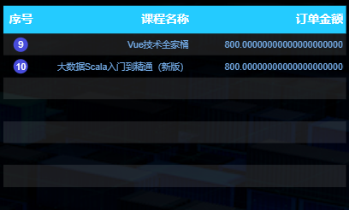

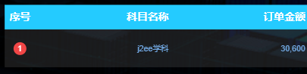

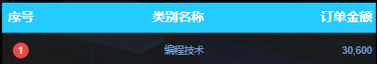

### 3.5.2 评价情况统计

**1）需求说明**

|  |  |  |  |
| --- | --- | --- | --- |
| 统计周期 | 统计粒度 | 指标 | 说明 |
| 当日 | 课程 | 用户平均评分 | 略 |
| 当日 | 课程 | 评价用户数 | 略 |
| 当日 | 课程 | 好评率 | 略 |

**2）需求分析**

本节指标的展示使用轮播表格实现。

**3）数据结构**

略。

**4）Mapper 层**

（1）实体类 **CourseReviewStats**

package com.atguigu.edu.publisher.bean;

import lombok.AllArgsConstructor;

import lombok.Data;

@Data

@AllArgsConstructor

public class CourseReviewStats {

// 课程名称

String courseName;

// 平均评分

Double avgStars;

// 评价用户数

Integer reviewUserCt;

// 好评用户数

Integer goodReviewUserCt;

// 好评率

Double goodReviewRate;

}

（2）Mapper 接口

在 CourseStatsMapper 接口中补充方法。

@Select("select course_name,\n" +

" sum(review_total_stars) review_total_stars,\n" +

" sum(review_user_count) review_user_count,\n" +

" sum(good_review_user_count) good_review_user_count,\n" +

" good_review_user_count / review_user_count good_review_rate\n" +

"from dws_interaction_course_review_window\n" +

"where toYYYYMMDD(stt) = #{date}\n" +

"group by course_id, course_name\n" +

"order by good_review_user_count desc\n" +

"limit 10;")

List<CourseReviewStats> selectCourseReviewStats(@Param("date") Integer date);

**5）Service 层**

（1）Service 接口

在 CourseStatsService 接口中补充方法。

List<CourseReviewStats> getCourseReviewStats(Integer date);

（2）Service 实现类

在 CourseStatsServiceImpl 实现类中补充方法。

@Override

public List<CourseReviewStats> getCourseReviewStats(Integer date) {

return courseStatsMapper.selectCourseReviewStats(date);

}

**6）Controller 层**

在 CourseStatsController 类中补充方法。

@RequestMapping("/courseReviewStats")

public String getCourseReviewStats(

@RequestParam(value = "date", defaultValue = "1") Integer date) {

if (date == 1) {

date = DateUtil.now();

}

List<CourseReviewStats> courseReviewStats = courseStatsService.getCourseReviewStats(date);

if (courseReviewStats == null || courseReviewStats.size() == 0) {

return "";

}

StringBuilder rows = new StringBuilder("[");

for (int i = 0; i < courseReviewStats.size(); i++) {

CourseReviewStats courseReviewStat = courseReviewStats.get(i);

String courseName = courseReviewStat.getCourseName();

Double avgStars = courseReviewStat.getAvgStars();

Integer reviewUserCt = courseReviewStat.getReviewUserCt();

Integer goodReviewUserCt = courseReviewStat.getGoodReviewUserCt();

Double goodReviewRate = courseReviewStat.getGoodReviewRate();

rows.append("{\n" +

"\t\"course_name\": \"" + courseName + "\",\n" +

"\t\"avg_stars\": \"" + avgStars + "\",\n" +

"\t\"review_user_ct\": \"" + reviewUserCt + "\",\n" +

"\t\"good_review_user_ct\": \"" + goodReviewUserCt + "\",\n" +

"\t\"good_review_rate\": \"" + goodReviewRate + "\"\n" +

"}");

if (i < courseReviewStats.size() - 1) {

rows.append(",");

} else {

rows.append("]");

}

}

String str = "{\n" +

" \"status\": 0,\n" +

" \"msg\": \"\",\n" +

" \"data\": {\n" +

" \"columns\": [\n" +

" {\n" +

" \"name\": \"课程名称\",\n" +

" \"id\": \"course_name\"\n" +

" },\n" +

" {\n" +

" \"name\": \"平均评分\",\n" +

" \"id\": \"avg_stars\"\n" +

" },\n" +

" {\n" +

" \"name\": \"评价人数\",\n" +

" \"id\": \"review_user_ct\"\n" +

" },\n" +

" {\n" +

" \"name\": \"好评人数\",\n" +

" \"id\": \"good_review_user_ct\"\n" +

" },\n" +

" {\n" +

" \"name\": \"好评率\",\n" +

" \"id\": \"good_review_rate\"\n" +

" }\n" +

" ],\n" +

" \"rows\": " + rows + "\n" +

" }\n" +

"}";

String finalStr = str.replaceAll("\\\\", ",");

return finalStr;

}

**7）Sugar 配置**

① 选择轮播表格，数据绑定方式为 “API 拉取”，输入数据接口的 URL，如下。

${EDU_HOST}/edu/realtime/course/courseReviewStats?date=${EDU_DATE}

② 效果如下

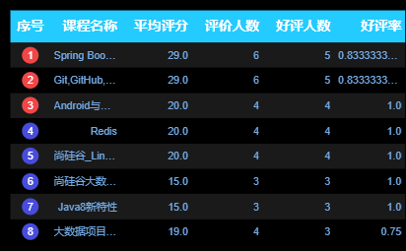

## 3.6 考试主题

### 3.6.1 各试卷考试统计

**1）需求说明**

|  |  |  |  |
| --- | --- | --- | --- |
| 统计周期 | 统计粒度 | 指标 | 说明 |
| 当日 | 试卷 | 考试人次 | 一名用户参与一次考试记一次 |
| 当日 | 试卷 | 平均分 | 总分 / 考试人次 |
| 当日 | 试卷 | 平均时长 | 考试总时长 / 考试人次 |

**2）需求分析**

本节指标使用轮播表格展示。

**3）数据结构**

前文已有展示，略。

**4）Mapper 层**

（1）实体类

package com.atguigu.edu.publisher.bean;

import lombok.AllArgsConstructor;

import lombok.Data;

@Data

@AllArgsConstructor

public class ExaminationPaperStats {

// 试卷名称

String paperTitle;

// 考试人次

Long examTakenCount;

// 试卷平均分

Double avgScore;

// 平均时长

Double avgSec;

}

（2）Mapper 接口

package com.atguigu.edu.publisher.mapper;

import com.atguigu.edu.publisher.bean.ExaminationCourseStats;

import com.atguigu.edu.publisher.bean.ExaminationPaperStats;

import com.atguigu.edu.publisher.bean.ExaminationQuestionStats;

import com.atguigu.edu.publisher.bean.ExaminationScoreDurDistribution;

import org.apache.ibatis.annotations.Param;

import org.apache.ibatis.annotations.Select;

import java.util.List;

public interface ExaminationStatsMapper {

@Select("select paper_title,\n" +

" sum(exam_taken_count) exam_taken_count,\n" +

" sum(exam_total_score) / exam_taken_count exam_avg_score,\n" +

" sum(exam_total_during_sec) / exam_taken_count exam_avg_sec\n" +

"from dws_examination_paper_exam_window\n" +

"where toYYYYMMDD(stt) = #{date}\n" +

"group by paper_id, paper_title\n" +

"order by exam_taken_count desc\n" +

"limit 10;")

List<ExaminationPaperStats> selectExaminationPaperStats(@Param("date") Integer date);

}

**5）Service 层**

（1）Service 接口

package com.atguigu.edu.publisher.service;

import com.atguigu.edu.publisher.bean.ExaminationCourseStats;

import com.atguigu.edu.publisher.bean.ExaminationPaperStats;

import com.atguigu.edu.publisher.bean.ExaminationQuestionStats;

import com.atguigu.edu.publisher.bean.ExaminationScoreDurDistribution;

import java.util.List;

public interface ExaminationStatsService {

List<ExaminationPaperStats> getExaminationPaperStats(Integer date);

}

（2）Service 实现类

package com.atguigu.edu.publisher.service.impl;

import com.atguigu.edu.publisher.bean.ExaminationCourseStats;

import com.atguigu.edu.publisher.bean.ExaminationScoreDurDistribution;

import com.atguigu.edu.publisher.mapper.ExaminationStatsMapper;

import com.atguigu.edu.publisher.service.ExaminationStatsService;

import com.atguigu.edu.publisher.bean.ExaminationPaperStats;

import com.atguigu.edu.publisher.bean.ExaminationQuestionStats;

import org.springframework.beans.factory.annotation.Autowired;

import org.springframework.stereotype.Service;

import java.util.List;

@Service

public class ExaminationStatsServiceImpl implements ExaminationStatsService {

@Autowired

ExaminationStatsMapper examinationStatsMapper;

@Override

public List<ExaminationPaperStats> getExaminationPaperStats(Integer date) {

return examinationStatsMapper.selectExaminationPaperStats(date);

}

}

**6）Controller 层**

package com.atguigu.edu.publisher.controller;

import com.atguigu.edu.publisher.bean.*;

import com.atguigu.edu.publisher.service.ExaminationStatsService;

import com.atguigu.edu.publisher.util.DateUtil;

import org.springframework.beans.factory.annotation.Autowired;

import org.springframework.web.bind.annotation.RequestMapping;

import org.springframework.web.bind.annotation.RequestParam;

import org.springframework.web.bind.annotation.RestController;

import java.util.List;

@RestController

@RequestMapping("/edu/realtime/examination")

public class ExaminationStatsController {

@Autowired

private ExaminationStatsService examinationStatsService;

@RequestMapping("/paperStats")

public String getExaminationPaperCt(

@RequestParam(value = "date", defaultValue = "1") Integer date) {

if (date == 1) {

date = DateUtil.now();

}

List<ExaminationPaperStats> examinationPaperStatsList = examinationStatsService.getExaminationPaperStats(date);

if (examinationPaperStatsList == null || examinationPaperStatsList.size() == 0) {

return "";

}

StringBuilder rows = new StringBuilder("[");

for (int i = 0; i < examinationPaperStatsList.size(); i++) {

ExaminationPaperStats examinationPaperStats = examinationPaperStatsList.get(i);

String paperTitle = examinationPaperStats.getPaperTitle();

Long examTakenCount = examinationPaperStats.getExamTakenCount();

Double avgScore = examinationPaperStats.getAvgScore();

Double avgSec = examinationPaperStats.getAvgSec();

rows.append("{\n" +

"\t\"paperTitle\": \"" + paperTitle + "\",\n" +

"\t\"examTakenCount\": \"" + examTakenCount + "\",\n" +

"\t\"avgScore\": \"" + avgScore + "\",\n" +

"\t\"avgSec\": \"" + avgSec + "\"\n" +

"}");

if (i < examinationPaperStatsList.size() - 1) {

rows.append(",");

} else {

rows.append("]");

}

}

return "{\n" +

" \"status\": 0,\n" +

" \"msg\": \"\",\n" +

" \"data\": {\n" +

" \"columns\": [\n" +

" {\n" +

" \"name\": \"试卷名称\",\n" +

" \"id\": \"paperName\"\n" +

" },\n" +

" {\n" +

" \"name\": \"考试人次\",\n" +

" \"id\": \"examTakenCount\"\n" +

" },\n" +

" {\n" +

" \"name\": \"平均分\",\n" +

" \"id\": \"avgScore\"\n" +

" },\n" +

" {\n" +

" \"name\": \"平均用时\",\n" +

" \"id\": \"avgSec\"\n" +

" }\n" +

" ],\n" +

" \"rows\": " + rows + "\n" +

" }\n" +

"}";

}

}

**7）Sugar 配置**

① 选择轮播表格，数据绑定方式为 “API 拉取”，输入数据接口的 URL，如下。

${EDU_HOST}/edu/realtime/examination/paperStats?date=${EDU_DATE}

② 效果如下

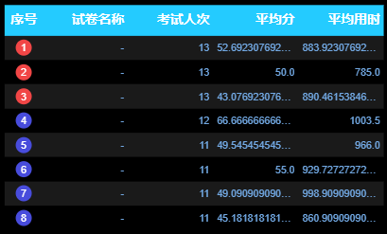

### 3.6.2 各课程考试统计

**1）需求说明**

|  |  |  |  |
| --- | --- | --- | --- |
| 统计周期 | 统计粒度 | 指标 | 说明 |
| 当日 | 课程 | 考试人次 | 一名用户参与一次考试记一次 |
| 当日 | 课程 | 平均分 | 总分 / 考试人次 |
| 当日 | 课程 | 平均时长 | 考试总时长 / 考试人次 |

**2）需求分析**

本节指标使用轮播表格展示。

**3）数据结构**

前文已有展示，略。

**4）Mapper 层**

（1）实体类

package com.atguigu.edu.publisher.bean;

import lombok.AllArgsConstructor;

import lombok.Data;

@Data

@AllArgsConstructor

public class ExaminationCourseStats {

// 课程名称

String courseName;

// 考试人次

Long examTakenCount;

// 试卷平均分

Double avgScore;

// 平均时长

Double avgSec;

}

（2）Mapper 接口

在 ExaminationStatsMapper 接口中补充方法

@Select("select course_name,\n" +

" sum(exam_taken_count) exam_taken_count,\n" +

" sum(exam_total_score) / exam_taken_count exam_avg_score,\n" +

" sum(exam_total_during_sec) / exam_taken_count exam_avg_sec\n" +

"from dws_examination_paper_exam_window\n" +

"where toYYYYMMDD(stt) = #{date}\n" +

"group by toYYYYMMDD(stt), course_id, course_name\n" +

"order by exam_taken_count desc\n" +

"limit 10;")

List<ExaminationCourseStats> selectExaminationCourseStats(@Param("date") Integer date);

**5）Service 层**

（1）Service 接口

在 ExaminationStatsService 接口中补充方法

List<ExaminationCourseStats> getExaminationCourseStats(Integer date);

（2）Service 实现类

在 ExaminationStatsServiceImpl 实现类中补充方法的实现

@Override

public List<ExaminationCourseStats> getExaminationCourseStats(Integer date) {

return examinationStatsMapper.selectExaminationCourseStats(date);

}

**6）Controller 层**

在 ExaminationStatsController 类中补充方法。

@RequestMapping("/courseStats")

public String getExaminationCourseCt(

@RequestParam(value = "date", defaultValue = "1") Integer date) {

if (date == 1) {

date = DateUtil.now();

}

List<ExaminationCourseStats> examinationCourseStatsList = examinationStatsService.getExaminationCourseStats(date);

if (examinationCourseStatsList == null || examinationCourseStatsList.size() == 0) {

return "";

}

StringBuilder rows = new StringBuilder("[");

for (int i = 0; i < examinationCourseStatsList.size(); i++) {

ExaminationCourseStats examinationCourseStats = examinationCourseStatsList.get(i);

String courseName = examinationCourseStats.getCourseName();

Long examTakenCount = examinationCourseStats.getExamTakenCount();

Double avgScore = examinationCourseStats.getAvgScore();

Double avgSec = examinationCourseStats.getAvgSec();

rows.append("{\n" +

"\t\"courseName\": \"" + courseName + "\",\n" +

"\t\"examTakenCount\": \"" + examTakenCount + "\",\n" +

"\t\"avgScore\": \"" + avgScore + "\",\n" +

"\t\"avgSec\": \"" + avgSec + "\"\n" +

"}");

if (i < examinationCourseStatsList.size() - 1) {

rows.append(",");

} else {

rows.append("]");

}

}

return "{\n" +

" \"status\": 0,\n" +

" \"msg\": \"\",\n" +

" \"data\": {\n" +

" \"columns\": [\n" +

" {\n" +

" \"name\": \"课程名称\",\n" +

" \"id\": \"courseName\"\n" +

" },\n" +

" {\n" +

" \"name\": \"考试人次\",\n" +

" \"id\": \"examTakenCount\"\n" +

" },\n" +

" {\n" +

" \"name\": \"平均分\",\n" +

" \"id\": \"avgScore\"\n" +

" },\n" +

" {\n" +

" \"name\": \"平均用时\",\n" +

" \"id\": \"avgSec\"\n" +

" }\n" +

" ],\n" +

" \"rows\": " + rows + "\n" +

" }\n" +

"}";

}

**7）Sugar 配置**

① 选择轮播表格，数据绑定方式为 “API 拉取”，输入数据接口的 URL，如下。

${EDU_HOST}/edu/realtime/examination/courseStats?date=${EDU_DATE}

② 效果如下

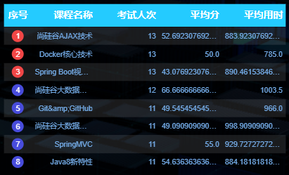

### 3.6.3 各试卷成绩分布

**1）需求说明**

|  |  |  |  |
| --- | --- | --- | --- |
| 统计周期 | 统计粒度 | 指标 | 说明 |
| 当日 | 试卷-分数段 | 人数 | 略 |

**2）需求分析**

本节指标使用饼状图展示。

**3）数据结构**

{

"status": 0,

"msg": "",

"data": [

{

"name": "PC",

"value": 97,

"url": "http://www.baidu.com"

},

{

"name": "iOS",

"value": 50,

"url": "http://www.baidu.com"

},

{

"name": "Android",

"value": 59,

"url": "http://www.baidu.com"

},

{

"name": "windows phone",

"value": 29

},

{

"name": "Black berry",

"value": 3

},

{

"name": "Nokia S60",

"value": 2

},

{

"name": "Nokia S90",

"value": 1

}

]

}

**4）Mapper 层**

（1）实体类

package com.atguigu.edu.publisher.bean;

import lombok.AllArgsConstructor;

import lombok.Data;

@Data

@AllArgsConstructor

public class ExaminationScoreDurDistribution {

// 分数段

String scoreDuration;

// 人数

Long userCout;

}

（2）Mapper 接口

在 ExaminationStatsMapper 接口中补充方法

@Select("select score_duration,\n" +

" sum(user_count) exam_taken_count\n" +

"from dws_examination_paper_score_duration_exam_window\n" +

"where toYYYYMMDD(stt) = #{date}\n" +

"group by score_duration\n" +

"order by score_duration;")

List<ExaminationScoreDurDistribution> selectExaminationScoreDurDistribution(@Param("date") Integer date);

**5）Service 层**

（1）Service 接口

在 ExaminationStatsService 接口中补充方法

List<ExaminationScoreDurDistribution> getExaminationScoreDurDistribution(Integer date);

（2）Service 实现类

在 ExaminationStatsServiceImpl 中补充方法的实现

@Override

public List<ExaminationScoreDurDistribution> getExaminationScoreDurDistribution(Integer date) {

return examinationStatsMapper.selectExaminationScoreDurDistribution(date);

}

**6）Controller 层**

在 ExaminationStatsController 中补充方法。

@RequestMapping("/scoreDurDistribution")

public String getScoreDurDistribution(

@RequestParam(value = "date", defaultValue = "1") Integer date) {

if (date == 1) {

date = DateUtil.now();

}

List<ExaminationScoreDurDistribution> examinationScoreDurDistributionList = examinationStatsService.getExaminationScoreDurDistribution(date);

if (examinationScoreDurDistributionList == null || examinationScoreDurDistributionList.size() == 0) {

return "";

}

StringBuilder data = new StringBuilder("[");

for (int i = 0; i < examinationScoreDurDistributionList.size(); i++) {

ExaminationScoreDurDistribution examinationScoreDurDistribution = examinationScoreDurDistributionList.get(i);

String scoreDuration = examinationScoreDurDistribution.getScoreDuration();

Long userCout = examinationScoreDurDistribution.getUserCout();

data.append("{\n" +

" \"name\": \"" + scoreDuration + "\",\n" +

" \"value\": " + userCout + "\n" +

" }");

if (i < examinationScoreDurDistributionList.size() - 1) {

data.append(",");

} else {

data.append("]");

}

}

return "{\n" +

" \"status\": 0,\n" +

" \"msg\": \"\",\n" +

" \"data\": " + data + "\n" +

"}";

}

**7）Sugar 配置**

① 选择环形饼图

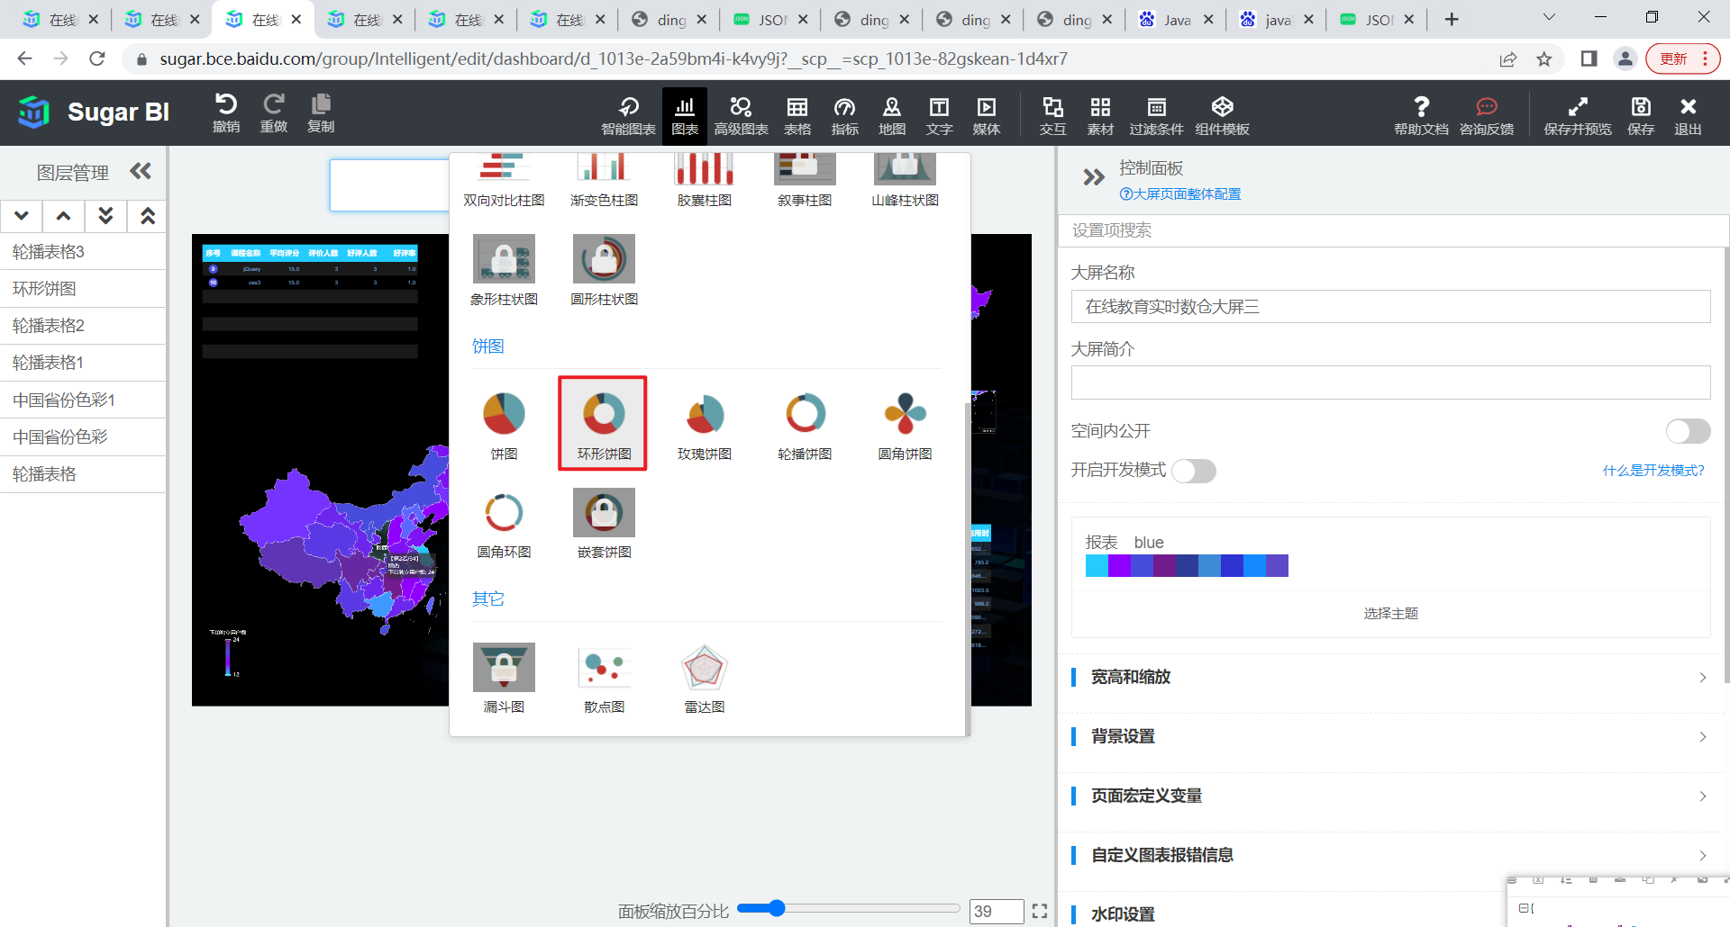

② 数据绑定方式为 “API 拉取”，输入数据接口的 URL，如下。

${EDU_HOST}/edu/realtime/examination/ scoreDurDistribution?date=${EDU_DATE}

③ 效果如下

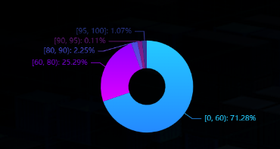

### 3.6.4 答题情况统计

**1）需求说明**

|  |  |  |  |
| --- | --- | --- | --- |
| 统计周期 | 统计粒度 | 指标 | 说明 |
| 当日 | 题目 | 正确答题次数 | 略 |
| 当日 | 题目 | 答题次数 | 略 |
| 当日 | 题目 | 正确率 | 正确答题次数 / 答题次数 |

**2）需求分析**

本节指标使用轮播表格展示。

**3）数据结构**

前文已有展示，略。

**4）Mapper 层**

（1）实体类

package com.atguigu.edu.publisher.bean;

import lombok.AllArgsConstructor;

import lombok.Data;

import org.springframework.util.DigestUtils;

import java.nio.charset.StandardCharsets;

@Data

@AllArgsConstructor

public class ExaminationQuestionStats {

// 题目

String questionTxt;

// 正确次数

Long correctAnswerCt;

// 答题次数

Long answerCt;

// 正确率

Double accuracyRate;

public String processQuestionTxt(){

String md5 = DigestUtils.md5DigestAsHex(questionTxt.getBytes(StandardCharsets.UTF_8));

return md5.substring(0, 10);

}

}

（2）Mapper 接口

在 ExaminationStatsMapper 接口中补充方法。

@Select("select question_txt,\n" +

" sum(correct_answer_count) correct_answer_count,\n" +

" sum(answer_count) answer_count,\n" +

" round(round(toFloat64(correct_answer_count), 5) " +

" / round(toFloat64(answer_count), 5), 20) accuracy_rate\n" +

"from dws_examination_question_answer_window\n" +

"where toYYYYMMDD(stt) = #{date}\n" +

"group by question_id,\n" +

" question_txt\n" +

"order by accuracy_rate desc\n" +

"limit 10;")

List<ExaminationQuestionStats> selectExaminationQuestionStats(@Param("date") Integer date);

**5）Service 层**

（1）Service 接口

在 ExaminationStatsService 接口中补充方法

List<ExaminationQuestionStats> getExaminationQuestionStats(Integer date);

（2）Service 实现类

在 ExaminationStatsServiceImpl 实现类中补充方法

@Override

public List<ExaminationQuestionStats> getExaminationQuestionStats(Integer date) {

return examinationStatsMapper.selectExaminationQuestionStats(date);

}

**6）Controller 层**

在 ExaminationStatsController 类中补充方法

@RequestMapping("/questionStats")

public String getExaminationQuestionStats(

@RequestParam(value = "date", defaultValue = "1") Integer date) {

if (date == 1) {

date = DateUtil.now();

}

List<ExaminationQuestionStats> examinationQuestionStatsList = examinationStatsService.getExaminationQuestionStats(date);

if (examinationQuestionStatsList == null || examinationQuestionStatsList.size() == 0) {

return "";

}

StringBuilder rows = new StringBuilder("[");

for (int i = 0; i < examinationQuestionStatsList.size(); i++) {

ExaminationQuestionStats examinationQuetstionCt = examinationQuestionStatsList.get(i);

String questionTxt = examinationQuetstionCt.processQuestionTxt();

Long answerCt = examinationQuetstionCt.getAnswerCt();

Long correctAnswerCt = examinationQuetstionCt.getCorrectAnswerCt();

Double accuracyRate = examinationQuetstionCt.getAccuracyRate();

rows.append("{\n" +

"\t\"questionTxt\": \"" + questionTxt + "\",\n" +

"\t\"answerCt\": \"" + answerCt + "\",\n" +

"\t\"correctAnswerCt\": \"" + correctAnswerCt + "\",\n" +

"\t\"accuracyRate\": \"" + accuracyRate + "\"\n" +

"}");

if (i < examinationQuestionStatsList.size() - 1) {

rows.append(",");

} else {

rows.append("]");

}

}

return "{\n" +

" \"status\": 0,\n" +

" \"msg\": \"\",\n" +

" \"data\": {\n" +

" \"columns\": [\n" +

" {\n" +

" \"name\": \"题目内容\",\n" +

" \"id\": \"questionTxt\"\n" +

" },\n" +

" {\n" +

" \"name\": \"答题次数\",\n" +

" \"id\": \"answerCt\"\n" +

" },\n" +

" {\n" +

" \"name\": \"正确答题次数\",\n" +

" \"id\": \"correctAnswerCt\"\n" +

" },\n" +

" {\n" +

" \"name\": \"正确率\",\n" +

" \"id\": \"accuracyRate\"\n" +

" }\n" +

" ],\n" +

" \"rows\": " + rows + "\n" +

" }\n" +

"}";

}

**7）Sugar 配置**

① 选择轮播表格，数据绑定方式为 “API 拉取”，输入数据接口的 URL，如下。

${EDU_HOST}/edu/realtime/examination/ questionStats?date=${EDU_DATE}

② 效果如下

